 

Project and Professionalism (6CS007)

Artefact Design Service Ease

Student Id : 2065693

Student Name : Hridaya Bhattarai Group : LM6CG1

Supervisor : Johan Tandukar

Reader : Aatiz Ghimire

Cohort : 7

Submitted on : October 14 2023

Table of Contents

Functional Decomposition Diagram (FDD) 1

Registration and login System 2

User Management 16

Employee Management 24

Booking Management 35

Feedback Management 48

Entity Relationship Diagram 57

Conceptual ERD 57

Final ERD 58

Class Diagram 59

Data Dictionary 60

Test plan 62

SRS document 65

# Table of figures

Figure 1: FDD 1

Figure 2: Index for different Artefacts 1

Figure 3: Use Case (RL) 2

Figure 4: Activity Diagram-RL (1) 3

Figure 5: Activity Diagram-RL (2) 4

Figure 6: Activity Diagram-RL (3) 5

Figure 7: Sequence Diagram-RL (1) 6

Figure 8: Sequence Diagram-RL (2) 7

Figure 9: Sequence Diagram-RL (3) 8

Figure 10: Wireframe Design-RL (1) 9

Figure 11: Wireframe Design- RL (2) 10

Figure 12: Wireframe Design-RL (3) 10

Figure 13: Wireframe Design-RL (4) 11

Figure 14: Wireframe Design-RL (5) 11

Figure 15: Wireframe Design-RL (6) 12

Figure 16: Communication Diagram-RL (1) 13

Figure 17: Communication Diagram-RL (2) 14

Figure 18: Communication Diagram -RL (3) 15

Figure 19: Use Case -UM 16

Figure 20: Activity Diagram -UM (1) 17

Figure 21: Activity Diagram-UM (2) 18

Figure 22: Sequence Diagram-UM 19

Figure 23: Wireframe Design-UM (1) 20

Figure 24: Wireframe Design-UM (2) 21

Figure 25: Communication Diagram-UM (1) 22

Figure 26: Communication Diagram-EM (1) 23

Figure 27: Use Case-EM 24

Figure 28: Activity Diagram-EM (1) 25

Figure 29: Activity Diagram-EM (2) 26

Figure 30: Activity Diagram-EM (3) 27

Figure 31: Sequence Diagram-EM (1) 28

Figure 32: Sequence Diagram-EM (2) 29

Figure 33: Wireframe Design-EM (1) 30

Figure 34: Wireframe Design-EM (2) 31

Figure 35: Wireframe Design-EM (3) 32

Figure 36: Communication Diagram-EM (1) 33

Figure 37: Communication Diagram-EM (2) 34

Figure 38: Use Case- BM 35

Figure 39: Activity Diagram-BM (1) 36

Figure 40: Activity Diagram-BM (2) 37

Figure 41: Activity Diagram-BM (3) 38

Figure 42: Sequence Diagram-BM (1) 39

Figure 43: Sequence Diagram-BM (2) 40

Figure 44: Wireframe Design-BM (1) 41

Figure 45: Wireframe Design-BM (2) 42

Figure 46: Wireframe Design-BM (3) 43

Figure 47: Wireframe Design-BM (4) 44

Figure 48: Wireframe Design-BM (5) 45

Figure 49: Communication Diagram-BM (1) 46

Figure 50: Communication Diagram-BM (2) 47

Figure 51: Communication Diagram-BM (3) 47

Figure 52: Use Case-UEF 48

Figure 53: Activity Diagram-UEF (1) 49

Figure 54: Activity Diagram-UEF (2) 50

Figure 55: Sequence Diagram-UEF (1) 51

Figure 56: Sequence Diagram-UEF (2) 52

Figure 57: Wireframe Design-UEF (1) 53

Figure 58: Wireframe Design-UEF (2) 54

Figure 59: Communication Diagram-UEF (1) 55

Figure 60: Communication Diagram-UEF (2) 56

Figure 61: Conceptual Erd 57

Figure 62: Detailed ERD 58

Figure 63: Class Diagram 59

Figure 64: Test Plan-RL 62

Figure 65: Test Plan-UM 63

Figure 66: Test Plan-EM 63

Figure 67: Test Plan-BM 64

Figure 68: Test Plan-UEF 64

# Functional Decomposition Diagram (FDD)

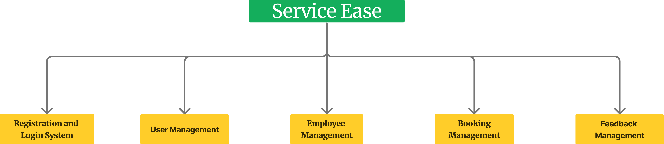

*Figure 1: FDD*

The above figure shows the breakdown of the different artefacts/ sub systems of my project Service Ease. The diagram highlights the major functions or processes to be carried out or performed by Service Ease. The FDD also highlights the scope and boundaries of my project, what it aims to complete and what are its limitations.

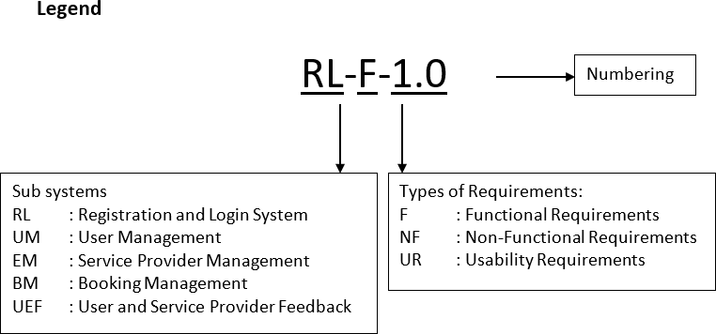

*Figure 2: Index for different Artefacts*

Here is the acronym used for different artefacts.

Registration and login System

## Use case

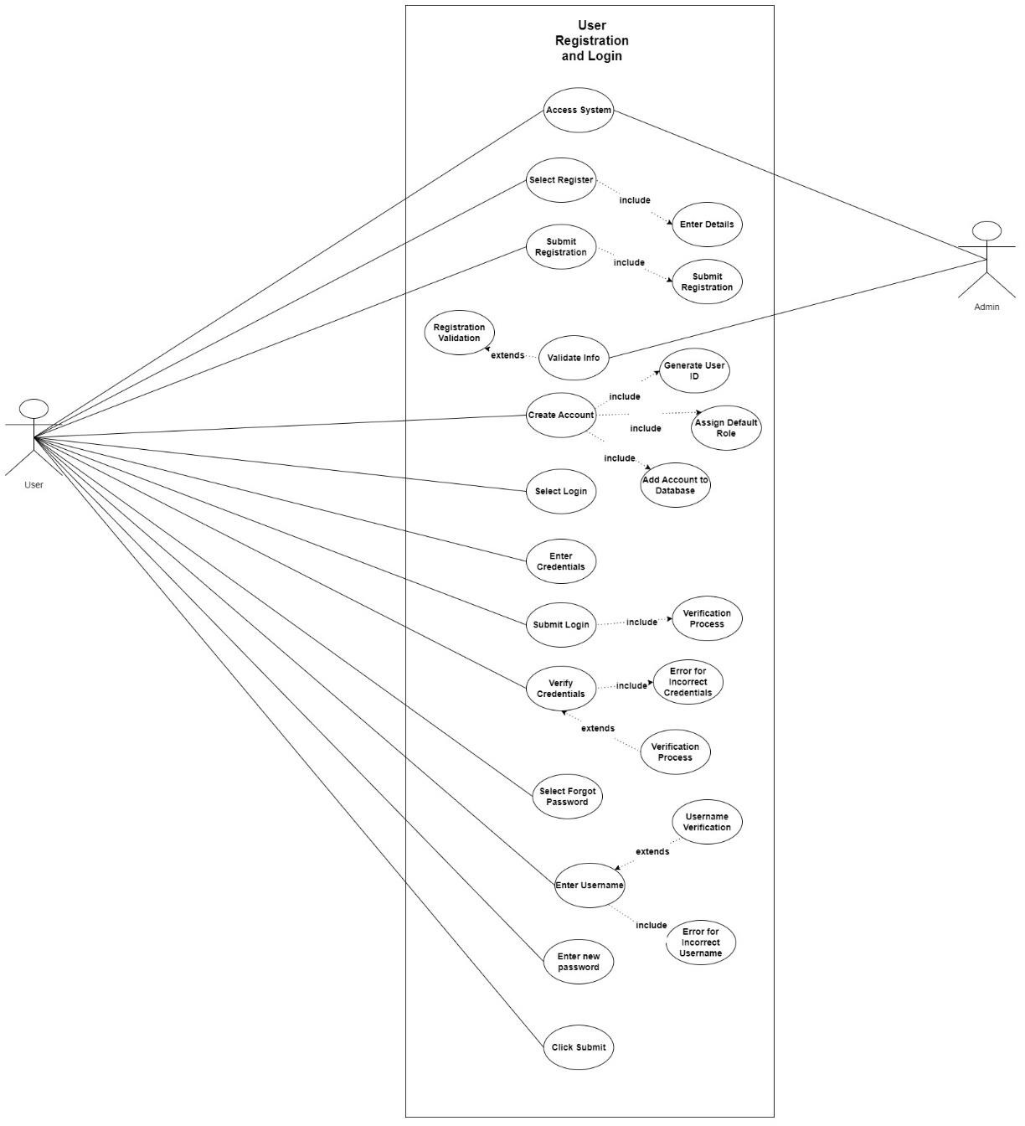

*Figure 3: Use Case (RL)*

The above use case elaborates the flow of Registration and login artefact for my system. The user and employee are able to access the system, sign up and login. Additionally, they also can reset the password if they forget it**.** The actions such as create account, verify and store credentials, validating username/email for resetting password contains different requisites to be fulfilled which are highlighted in the include tag.

## Activity Diagram

* + User Registration

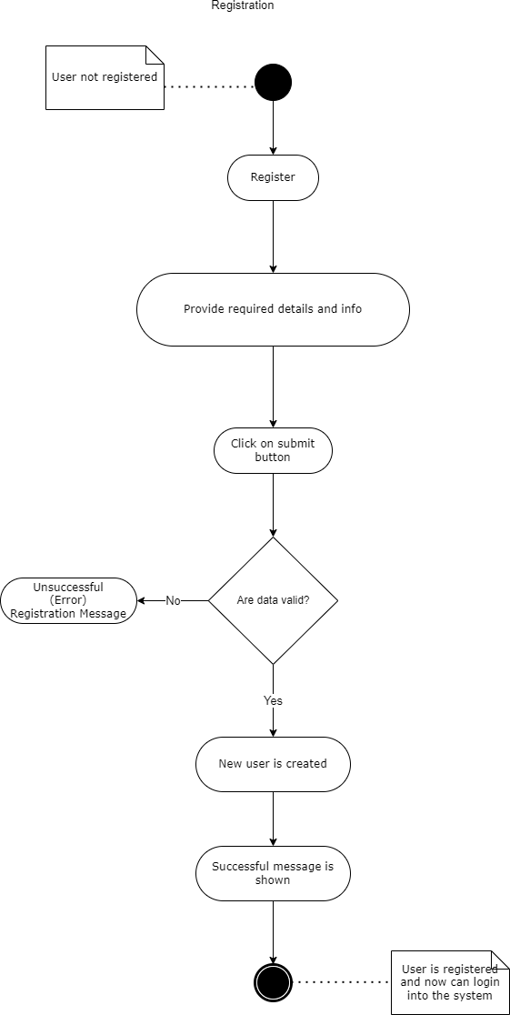

*Figure 4: Activity Diagram-RL (1)*

The diagram represents the flow or the actions to be taken while user registers into the system. The diagram helps to visualize all the work to be carried out on the user side upon he/she tries to register into the system. The un-registered user successfully registers into the system at the end of this activity.

* + User Login

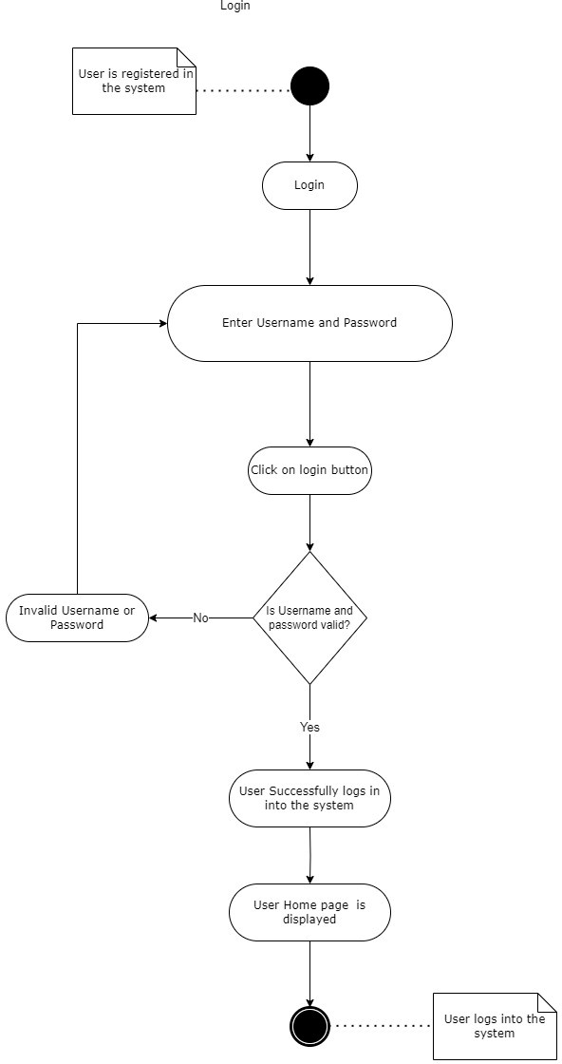

*Figure 5: Activity Diagram-RL (2)*

The diagram represents the flow or the actions to be taken while user tries to log in into the system. The diagram helps to visualize all the work to be carried out on the user side upon he/she tries to login into the system. At the end of this activity the user successfully logs in and is able to view the respective dashboard.

* + Forgot Password

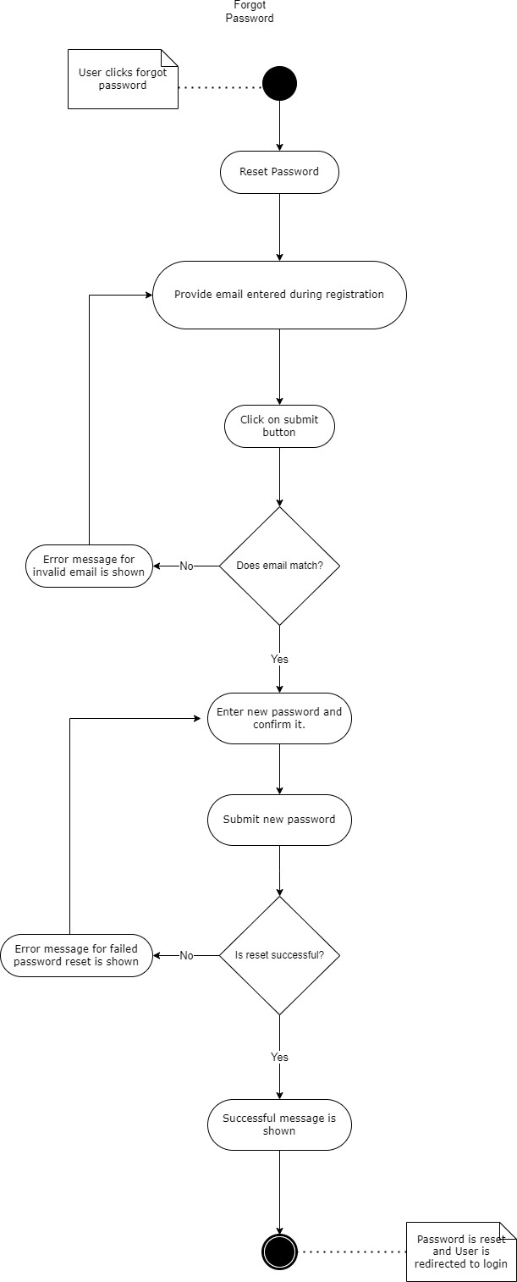

*Figure 6: Activity Diagram-RL (3)*

The diagram represents the activity to be taken out while user tries to reset the forgotten password. The visualization of user side actions while trying to reset the password is shown with this diagram. At the end of this activity the user is able to reset their password.

## Sequence Diagram

* + User Registration

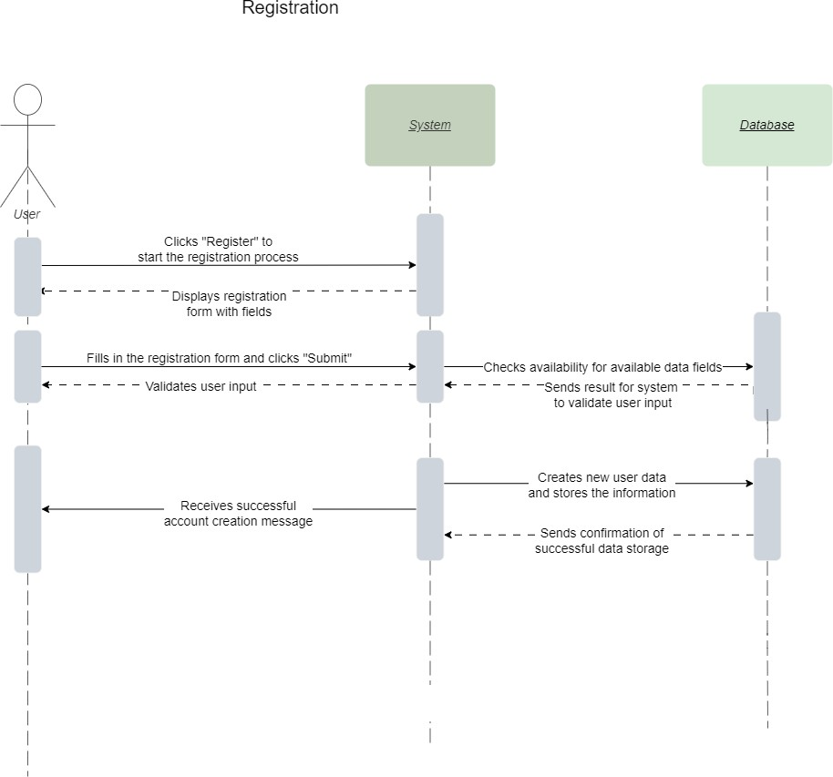

*Figure 7: Sequence Diagram-RL (1)*

The sequence diagram represents the interaction between the objects and the actor. In the above sequence the user`s interaction while registration activity is highlighted. All the interaction of user with different objects are highlighted in this diagram.

* + User login

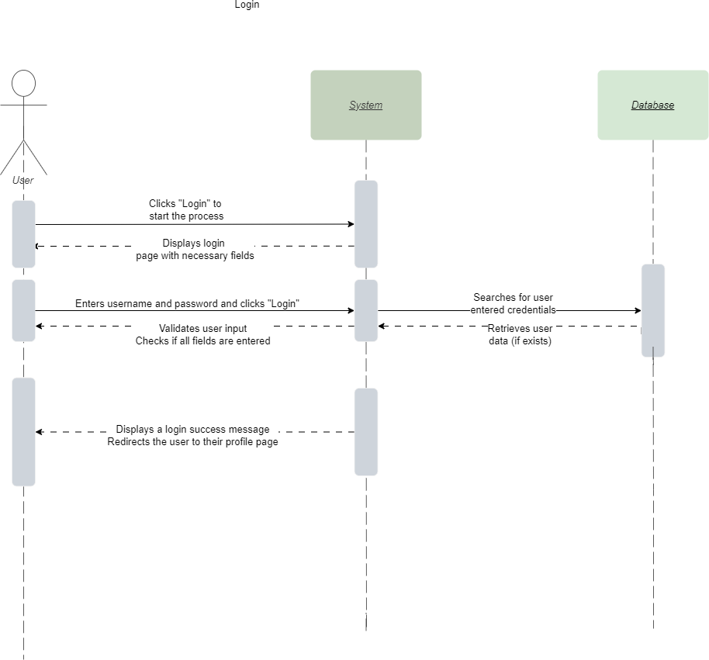

*Figure 8: Sequence Diagram-RL (2)*

The sequence diagram represents the interaction between the objects and the user actor. In the above sequence the user`s interaction while login activity is highlighted. All the interaction of user with different objects are highlighted in this diagram. The user side interaction is highlighted, which gives clear idea to the user trying to login.

* + Forgot Password

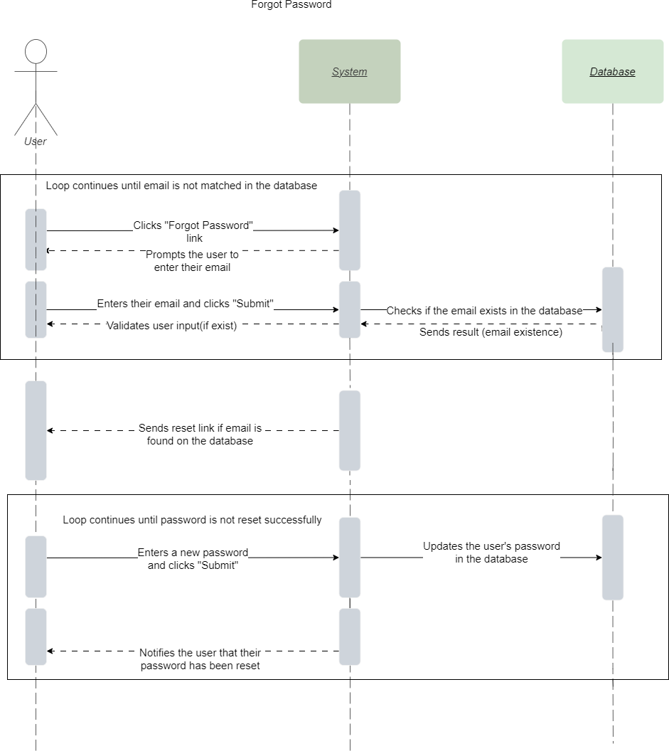

*Figure 9: Sequence Diagram-RL (3)*

In the above sequence the user`s interaction while reset password activity is highlighted. All the interaction of user with different objects are highlighted in this diagram. The user side interaction is highlighted, which gives clear idea to the user trying to reset the password. The rectangular box represents the interaction or the activity which happens on loop until a certain criterion is met. The loop is ended after the desired output is obtained.

## Wireframe Design

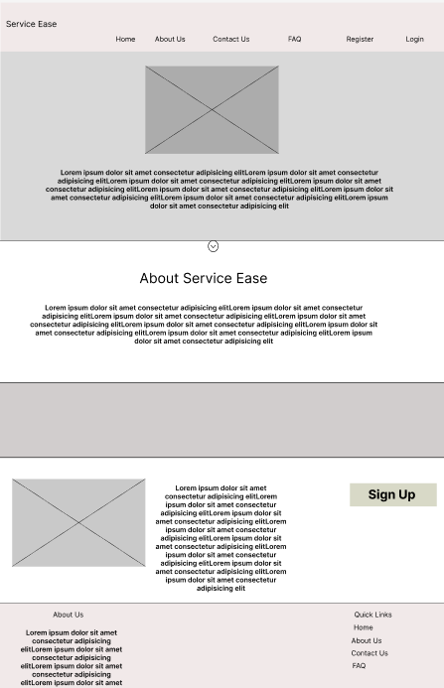

*Figure 10: Wireframe Design-RL (1)*

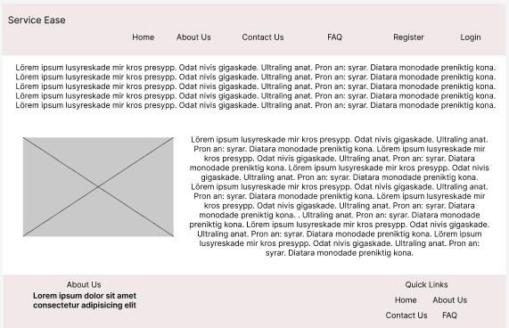

*Figure 11: Wireframe Design- RL (2)*

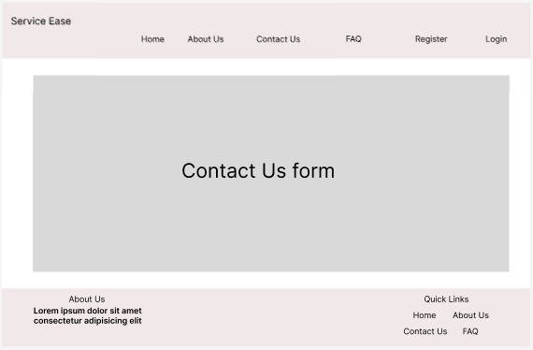

*Figure 12: Wireframe Design-RL (3)*

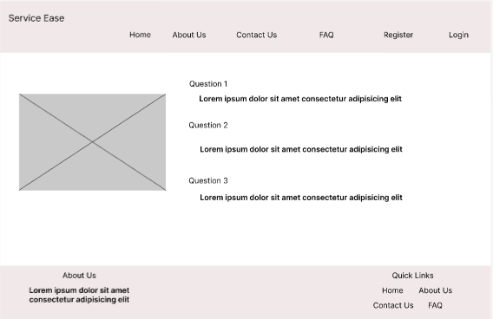

*Figure 13: Wireframe Design-RL (4)*

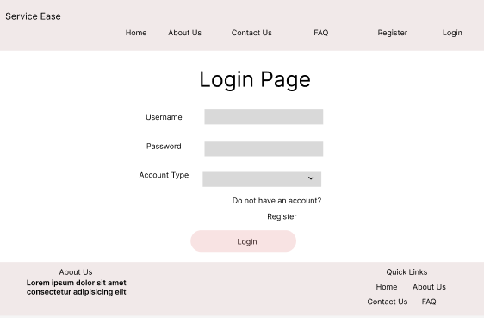

*Figure 14: Wireframe Design-RL (5)*

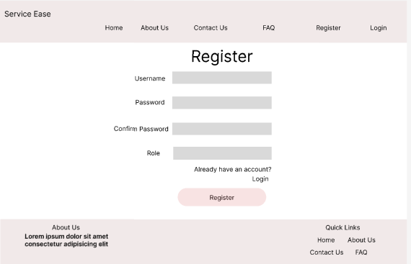

*Figure 15: Wireframe Design-RL (6)*

The Basic user UI for flow of the user is shown in the above wireframes for user registration activity.

## Communication Diagram

* + Registration

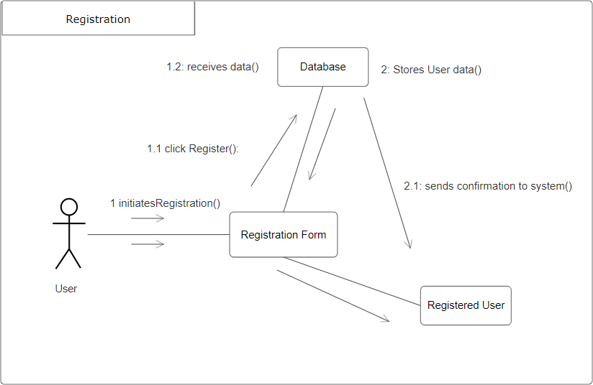

*Figure 16: Communication Diagram-RL (1)*

The above diagram shows the interaction between the user (actor), user interface, database and registration activity. All the communication and interaction occurring during the registration activity is highlighted in the above diagram.

* + Login

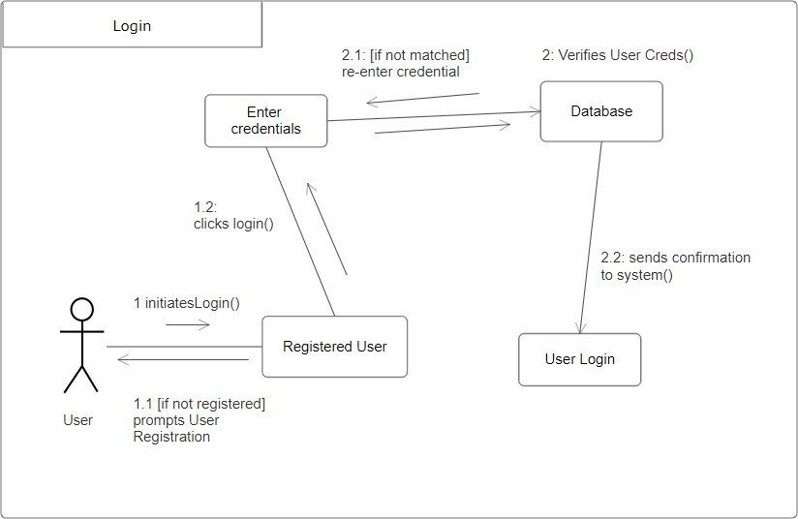

*Figure 17: Communication Diagram-RL (2)*

The above diagram shows the interaction between the user (actor), user interface, database and login activity. All the communication and interaction occurring during the login activity is highlighted in the above diagram.

* + Forgot Password

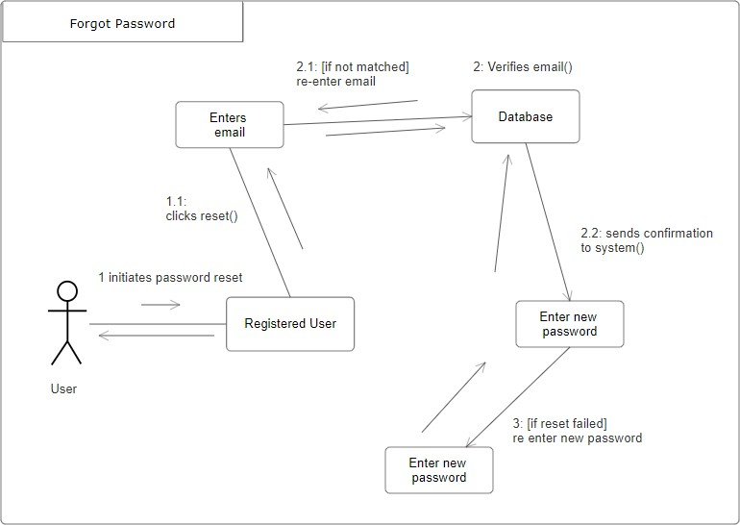

*Figure 18: Communication Diagram -RL (3)*

The above diagram shows the interaction between the user (actor), user interface, database and forgot password activity. All the communication and interaction occurring during the forgot password activity is highlighted in the above diagram.

User Management

## Use case

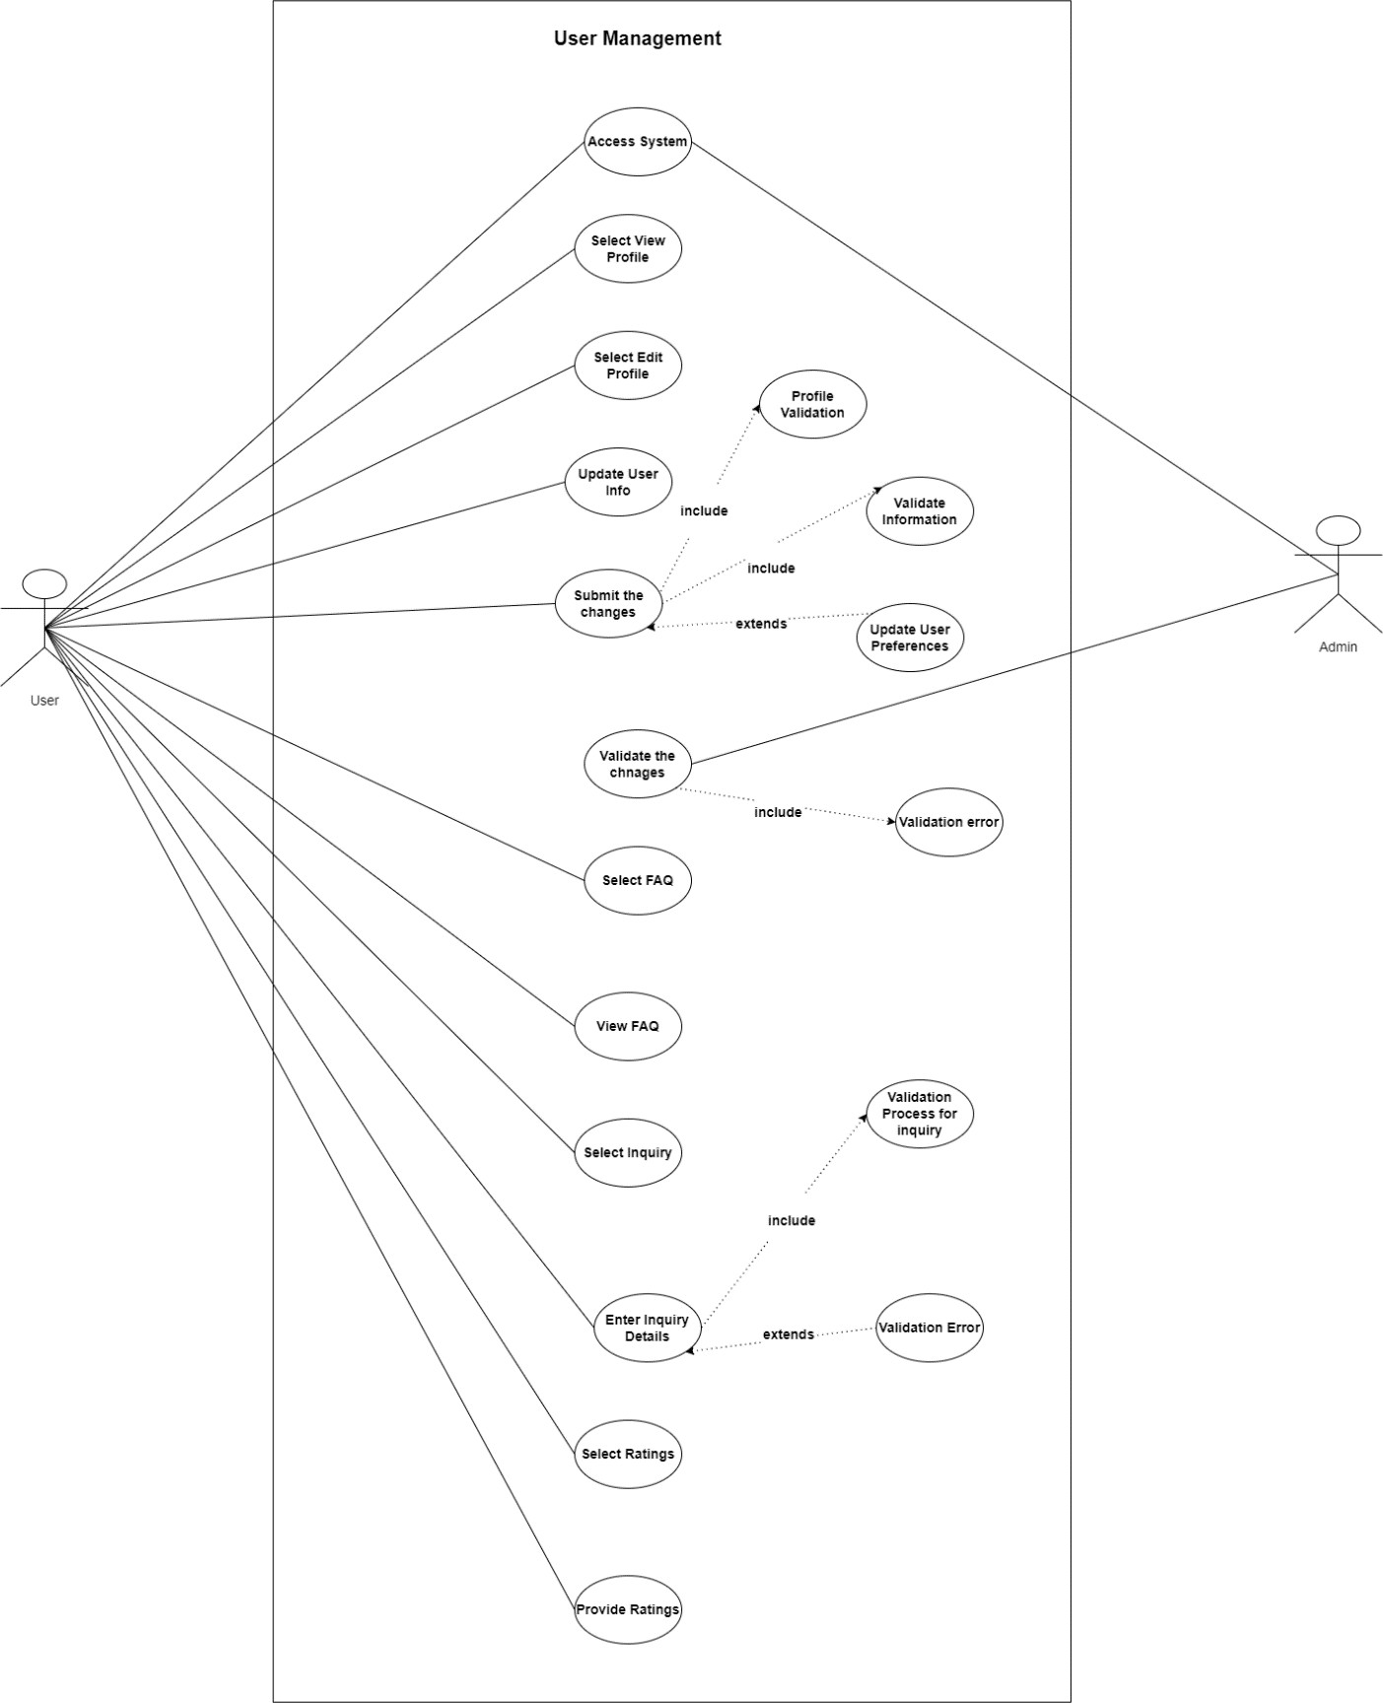

*Figure 19: Use Case -UM*

The above diagram is the use case diagram for user management artefact. User and admin are the two actors participating in the use case. The use case describes the flow of the user actions. The user actions are highlighted as user can view and edit their respective profile and also send inquiry to the admin.

## Activity Diagram

* + Inquiry

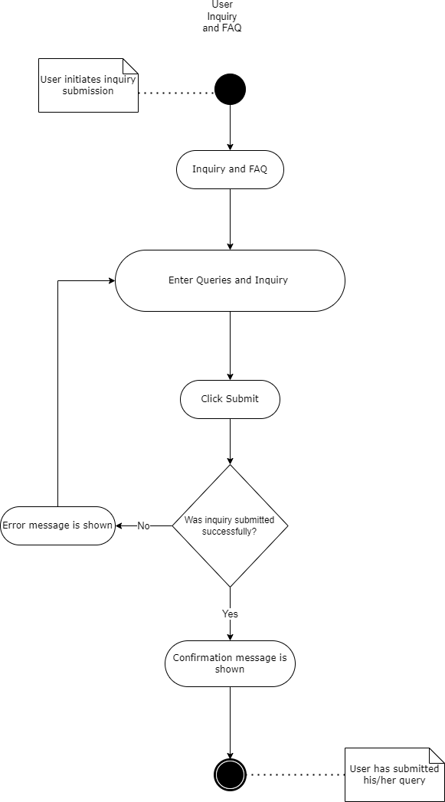

*Figure 20: Activity Diagram -UM (1)*

The above diagram shows the user actions while trying to post their inquiry. At the end of this activity the user is able to post their inquiry from the system successfully.

* + User Profile Update

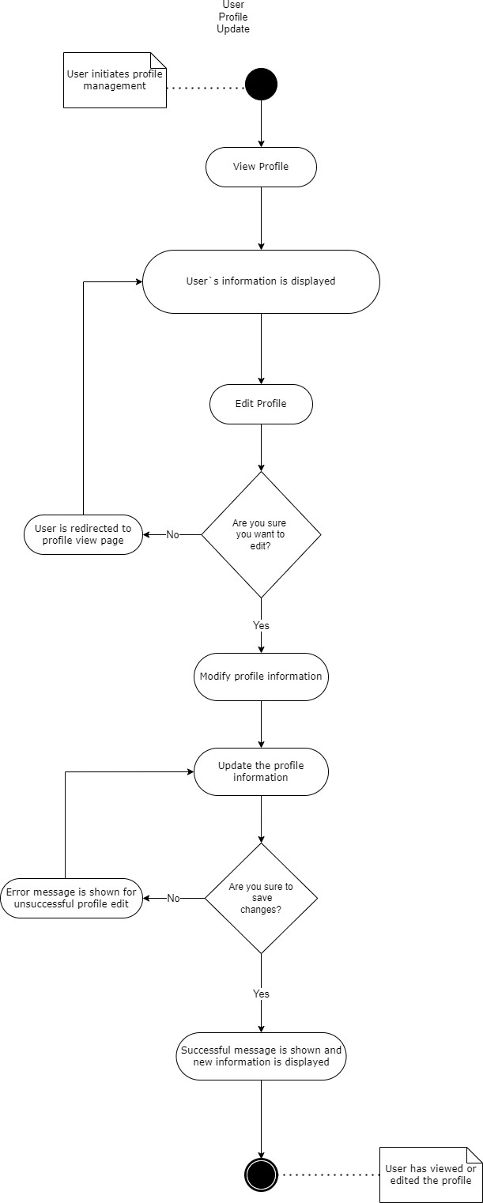

*Figure 21: Activity Diagram-UM (2)*

The above diagram shows the user actions while trying to update the profile information. The user when tries to update their profile, will have to go through all the process mentioned in the diagram. At the end of this activity the user is able to update their profile information successfully.

## Sequence Diagram

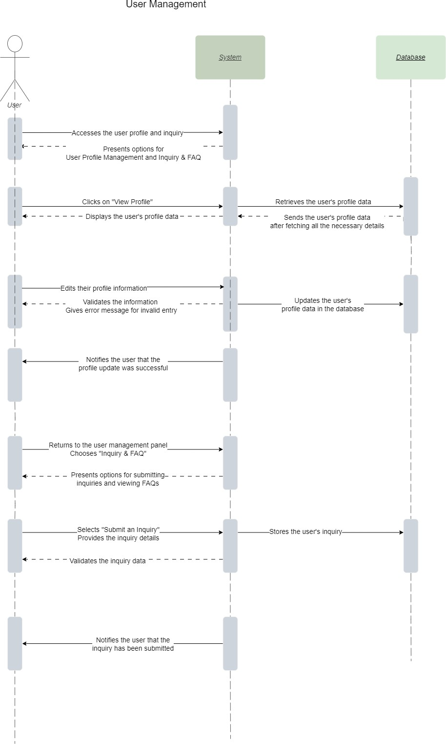

*Figure 22: Sequence Diagram-UM*

The following sequence diagram shows the interaction between the actor(user) and the objects during the user management activity. It shows how the interactions occurs while user management action is carried out.

## Wireframe Design

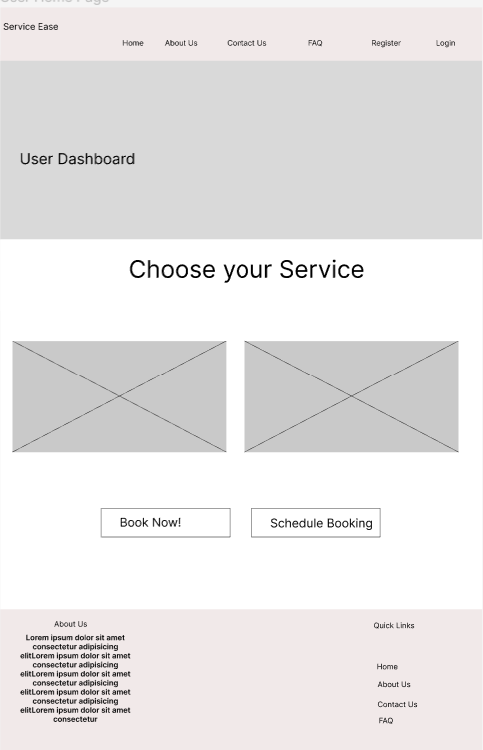

*Figure 23: Wireframe Design-UM (1)*

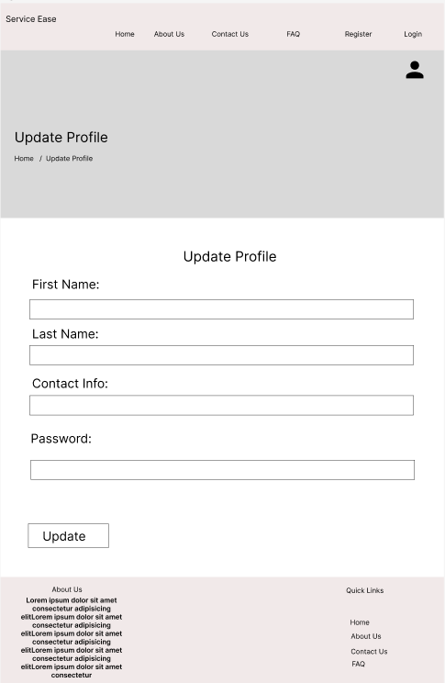

*Figure 24: Wireframe Design-UM (2)*

## Communication Diagram

* + User Views Profile

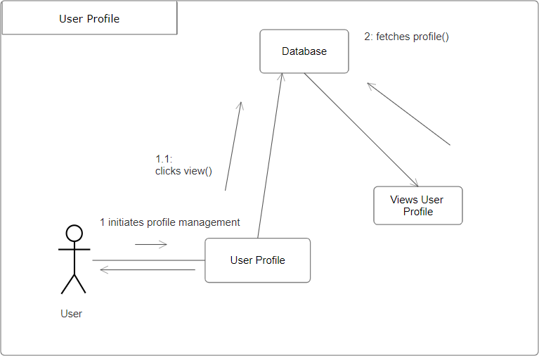

*Figure 25: Communication Diagram-UM (1)*

The communication diagram above represents the messages or communication passed through different components while user is trying is view their profile. The diagram reflects the message interchanged between the different system components.

* User Edits Profile

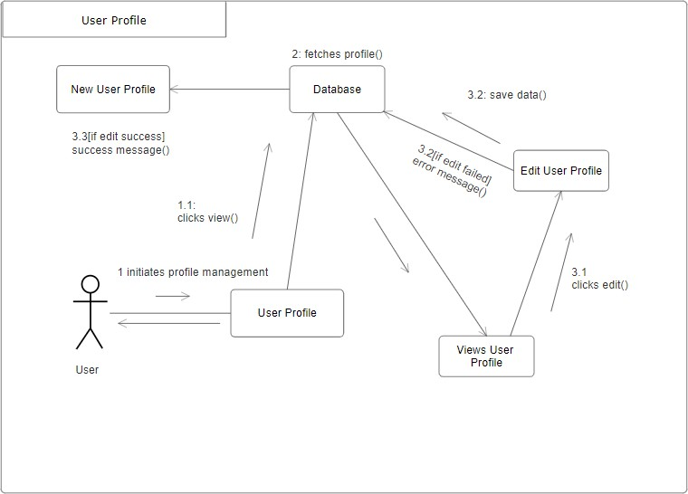

*Figure 26: Communication Diagram-EM (1)*

The communication diagram above represents the messages or communication passed through different components while user is trying is edit their profile. The diagram reflects the message interchanged between the different system components.

Employee Management

## Use case

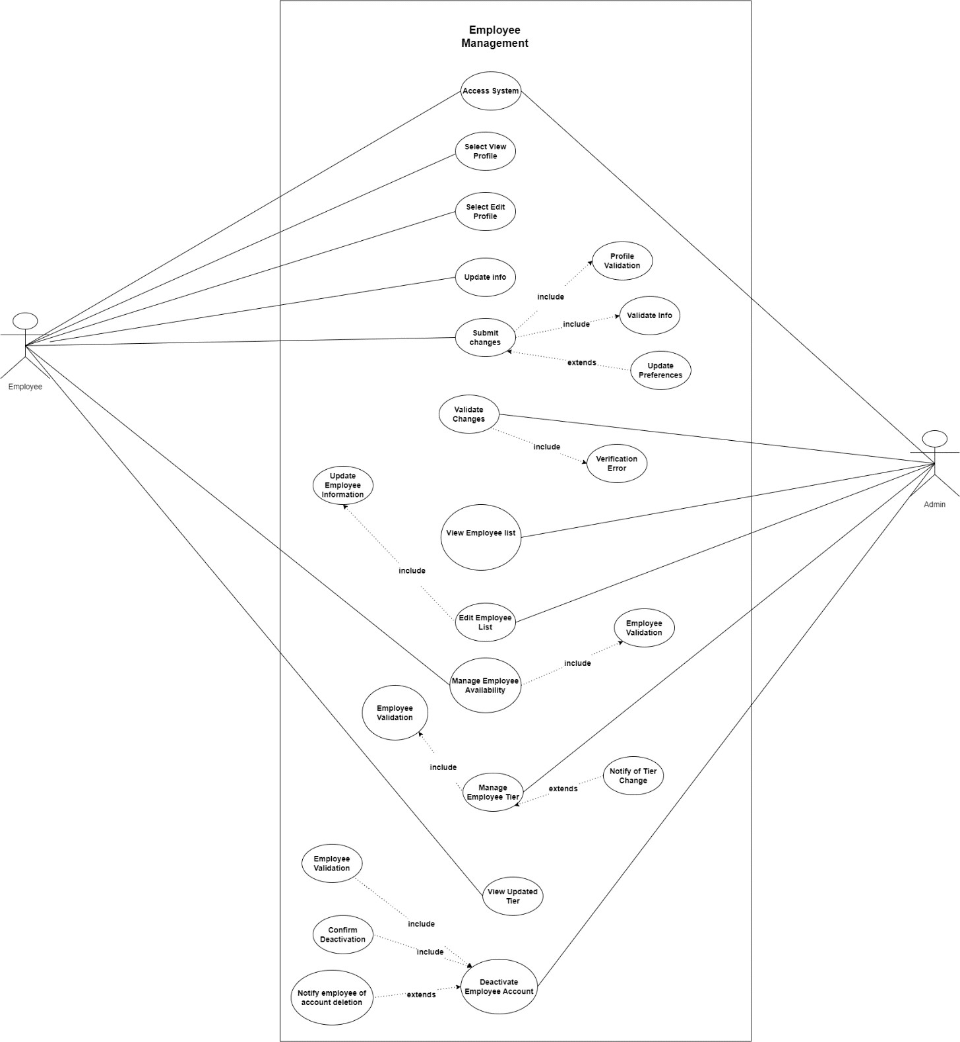

*Figure 27: Use Case-EM*

The above diagram is the use case diagram for employee management artefact. Employee and Admin are the two actors participating in the use case. The use case describes the flow of the employee actions. The employee actions are highlighted as they can view and edit their respective profile. Admin can also manage the tier of the employee

## Activity Diagram

* + Employee Profile

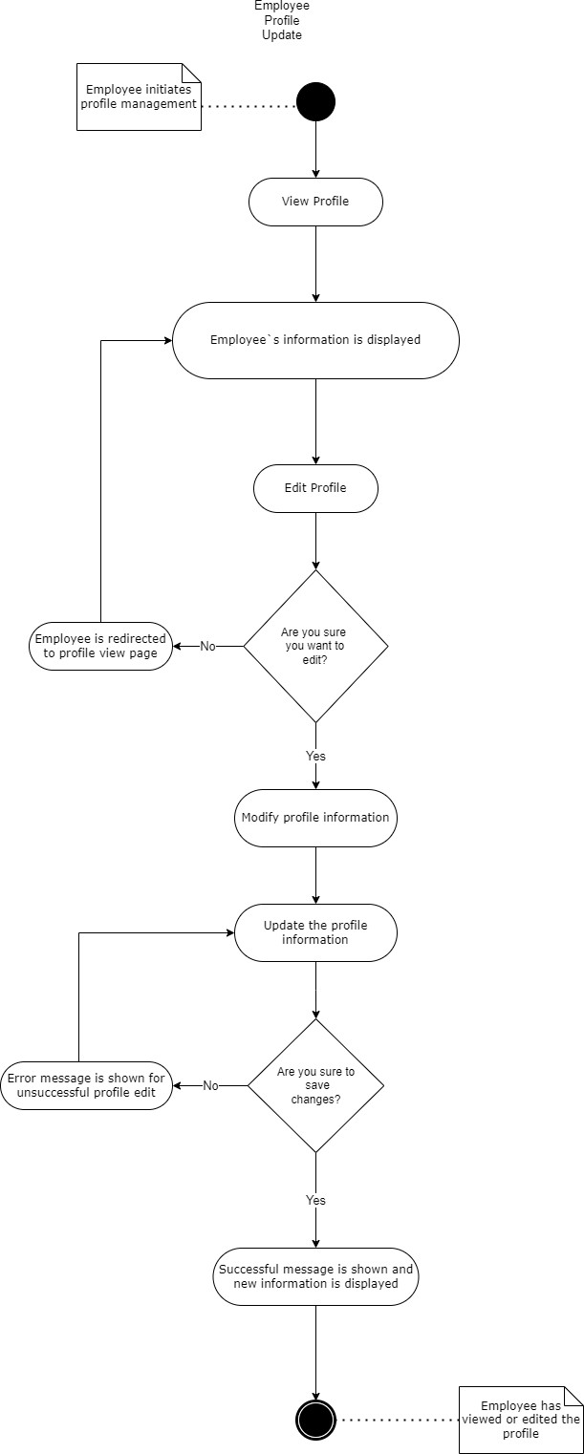

*Figure 28: Activity Diagram-EM (1)*

The above diagram shows the employee actions while trying to update the profile information. At the end of this activity the employee is able to update their profile information successfully.

* + Employee Availability

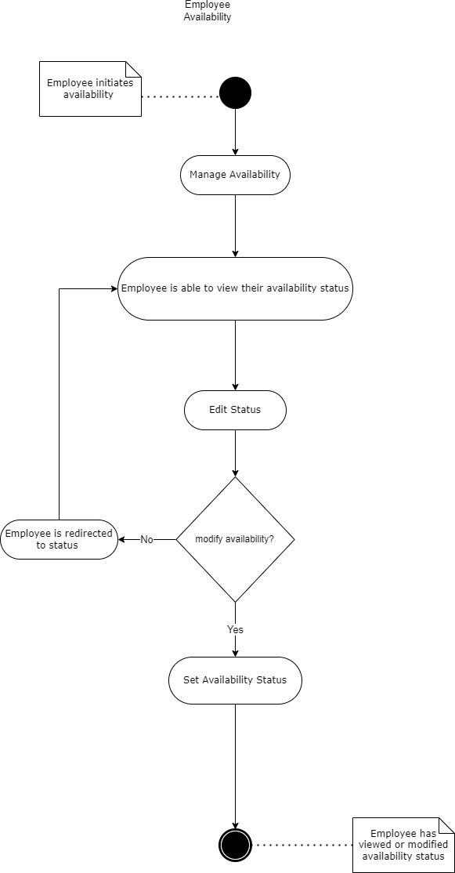

*Figure 29: Activity Diagram-EM (2)*

The above diagram shows the employee actions while trying to update their availability status. At the end of this activity the employee is able to update availability status successfully.

* + Employee Tier

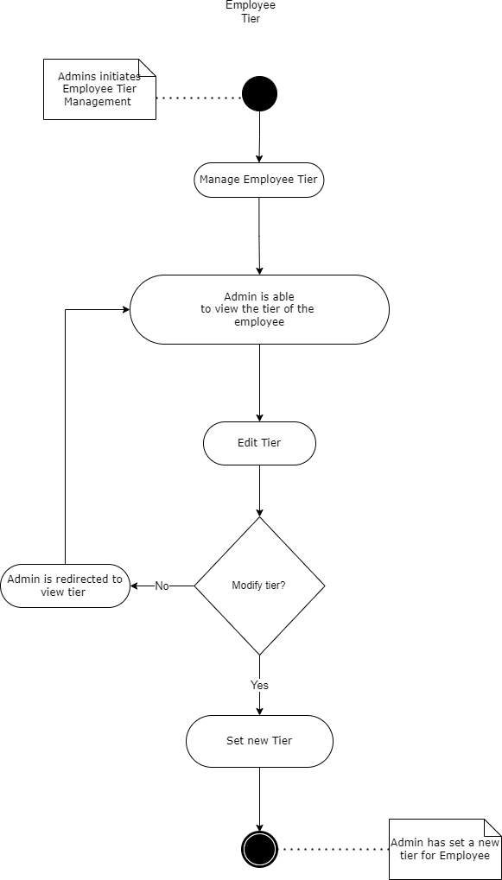

*Figure 30: Activity Diagram-EM (3)*

The above activity diagram shows the admin actions while setting the employee tier. All the actions to be carried out while performs this activity is listen in the diagram. At the completion of this activity the admin has successfully set the employee tier.

## Sequence Diagram

* + Employee Profile and availability

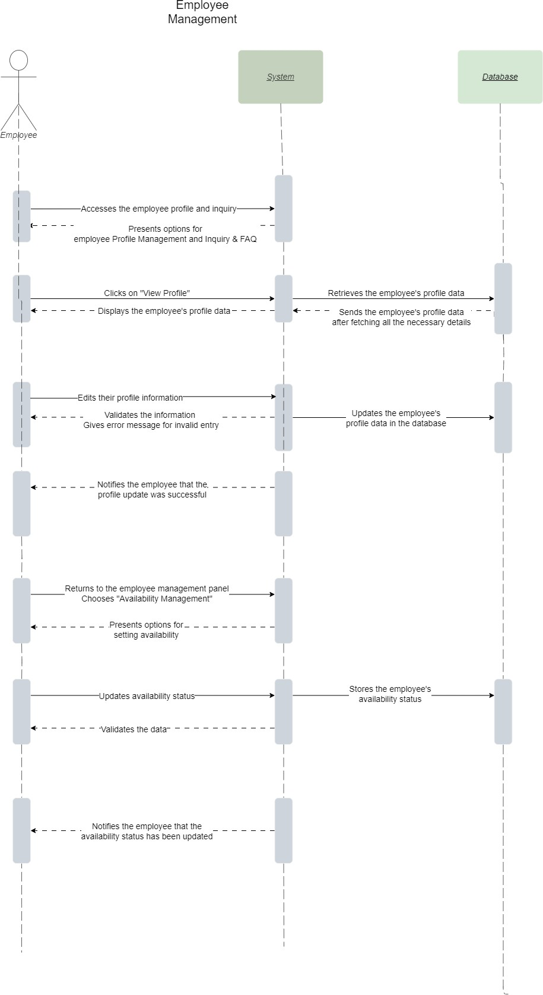

*Figure 31: Sequence Diagram-EM (1)*

The following sequence diagram shows the interaction between the actor(employee) and the objects during the employee management activity. It shows how the interactions

occurs while employee management action is carried out when employee updates their profile and status information.

* + Admin sets Employee Tier

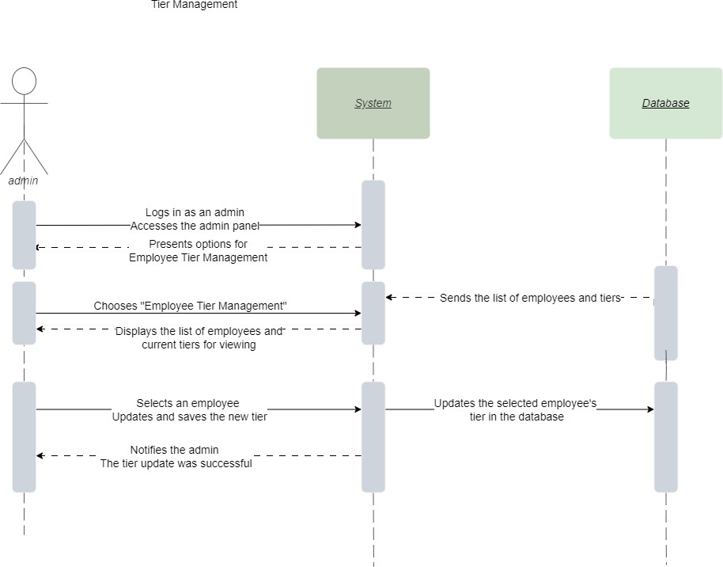

*Figure 32: Sequence Diagram-EM (2)*

The following sequence diagram shows the interaction between admin and the components while trying to set the employee tier. It reflects all the interaction to occur while employee tier activity is carried out.

## Wireframe design

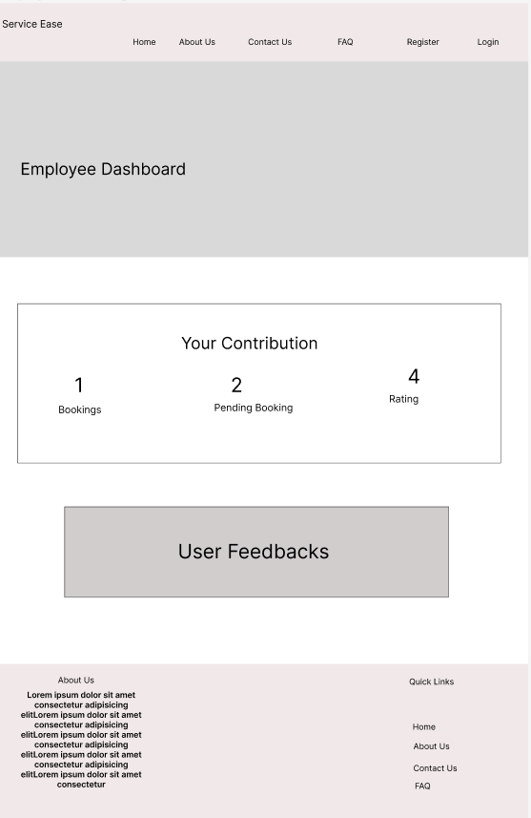

*Figure 33: Wireframe Design-EM (1)*

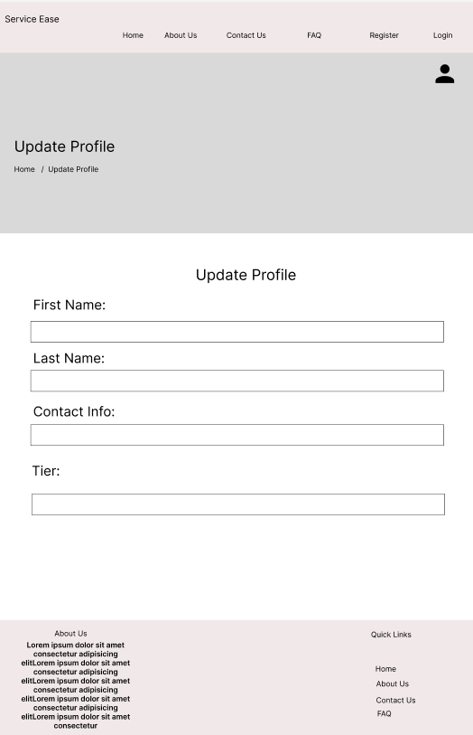

*Figure 34: Wireframe Design-EM (2)*

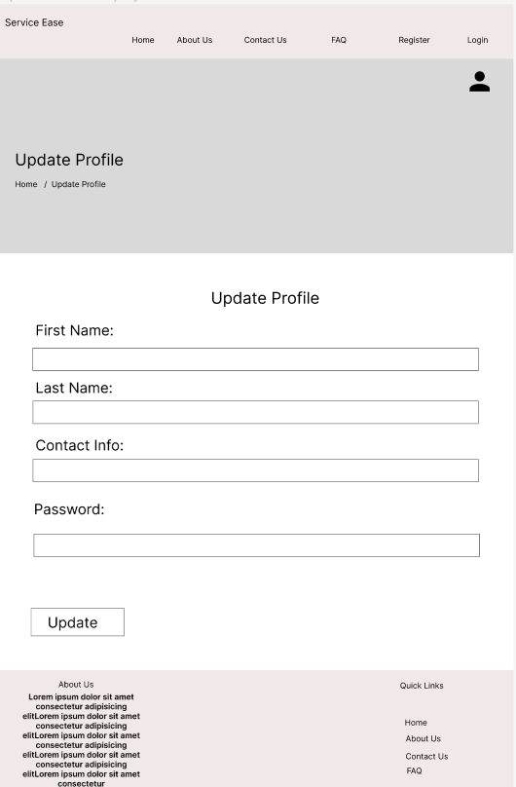

*Figure 35: Wireframe Design-EM (3)*

## Communication Diagram

* + Employee Profile

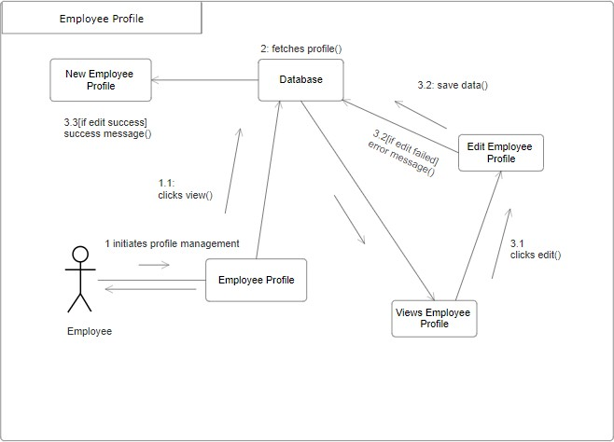

*Figure 36: Communication Diagram-EM (1)*

The communication diagram above represents the messages or communication passed through different components while employee is trying is edit their profile. The diagram reflects the message interchanged between the different system components.

* + Employee Tier

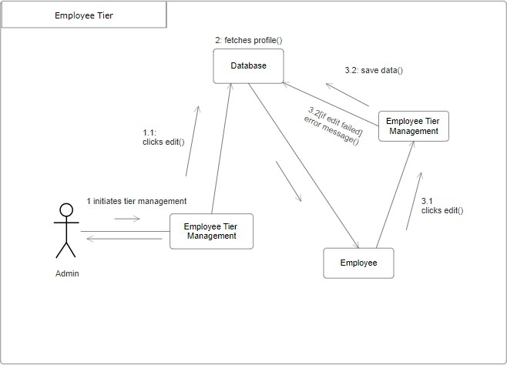

*Figure 37: Communication Diagram-EM (2)*

The above shown communication diagram reflects the communication between the different system components when admin is trying to set the employee tier. The flow of the messages among the different component of the system is reflected.

Booking Management

## Use case

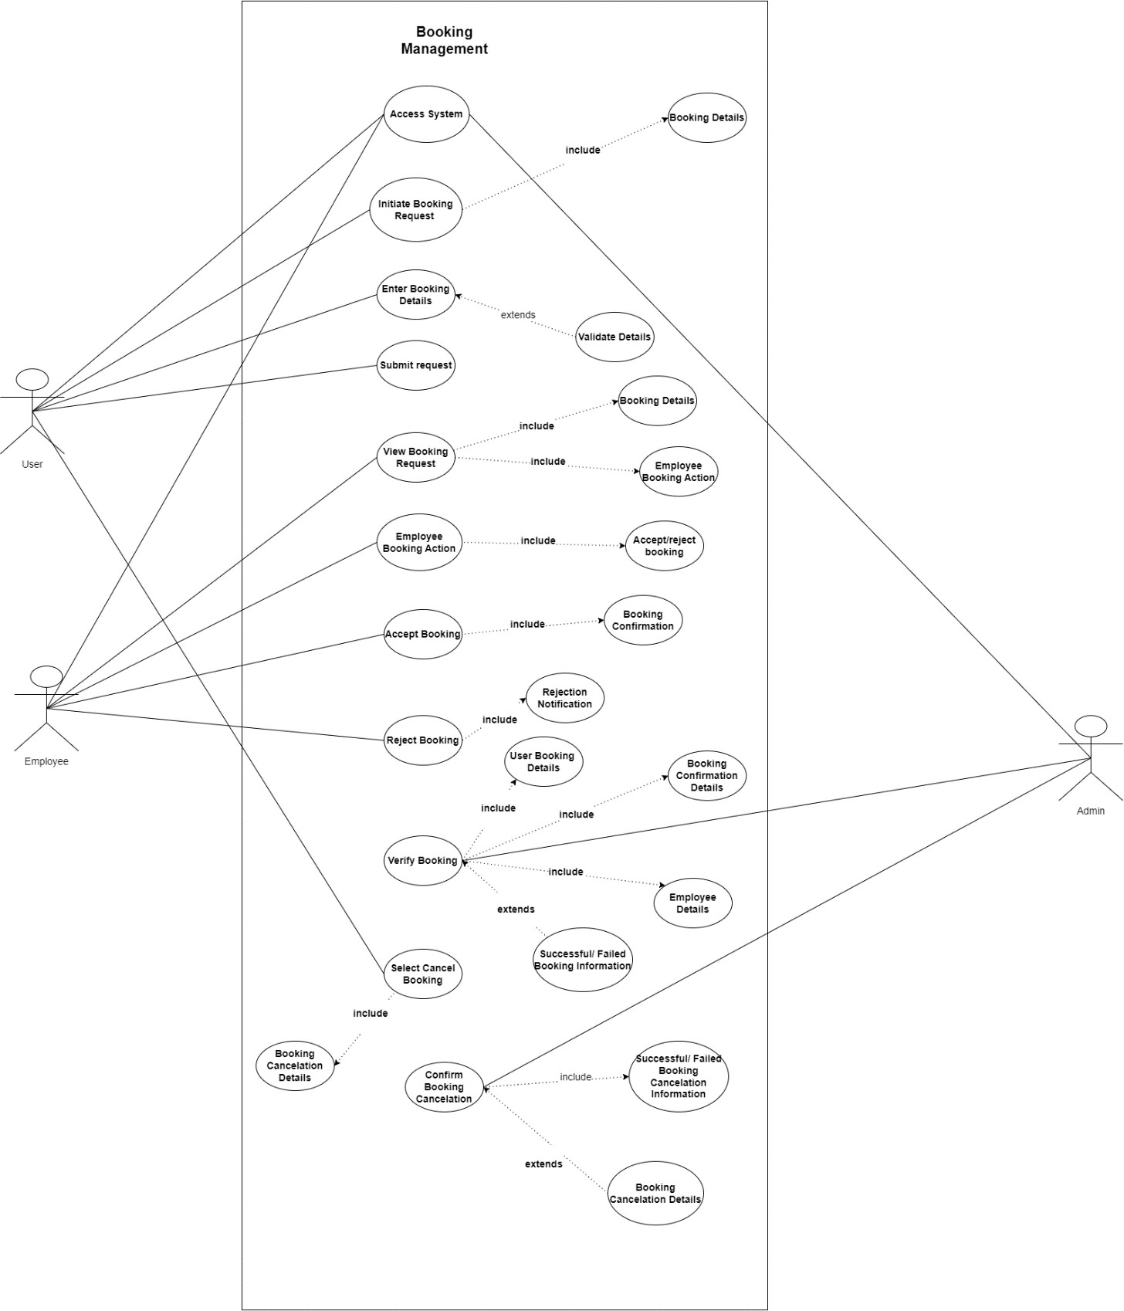

*Figure 38: Use Case- BM*

The above use case shows the flow for booking management artefact. Admin, User and Employee are the three actors for booking management. The use case reflects how the booking system works in this project. The interactions and actions of different actors while trying to have a successful booking is highlighted.

## Activity Diagram

* + User confirms booking

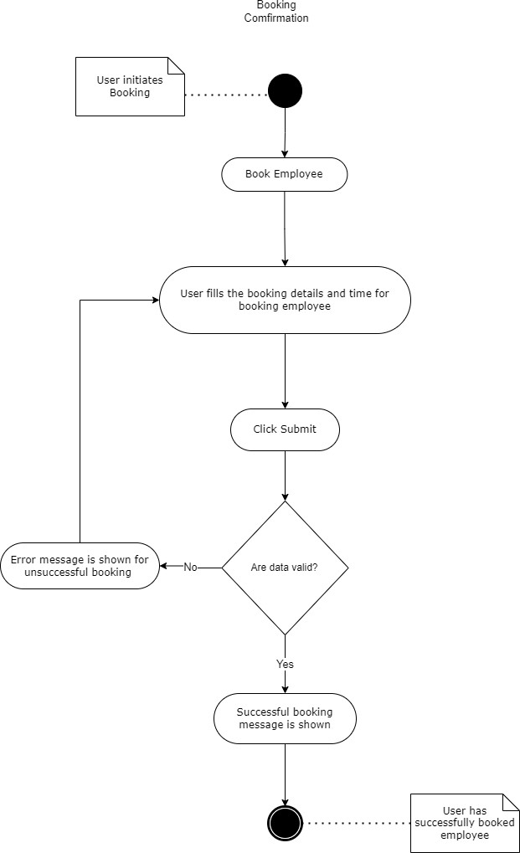

*Figure 39: Activity Diagram-BM (1)*

The above activity diagram reflects the action carried out during user`s attempt to successfully make a booking. At the end of this activity user will have successfully made a booking.

* + User Booking Cancellation

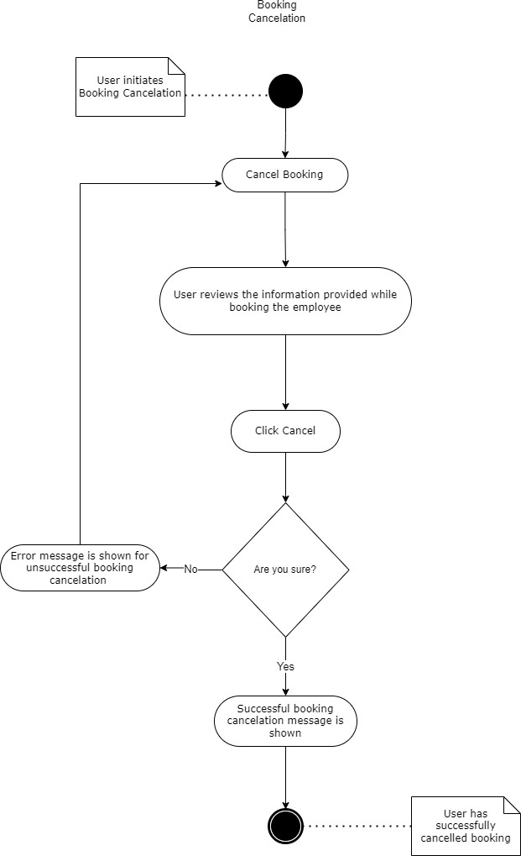

*Figure 40: Activity Diagram-BM (2)*

The above activity diagram reflects the action carried out during user`s attempt to successfully cancel a booking. At the end of this activity user will have successfully cancelled a booking. The diagram shows all the actions to be carried out during this effort.

* + Employee Views Booking

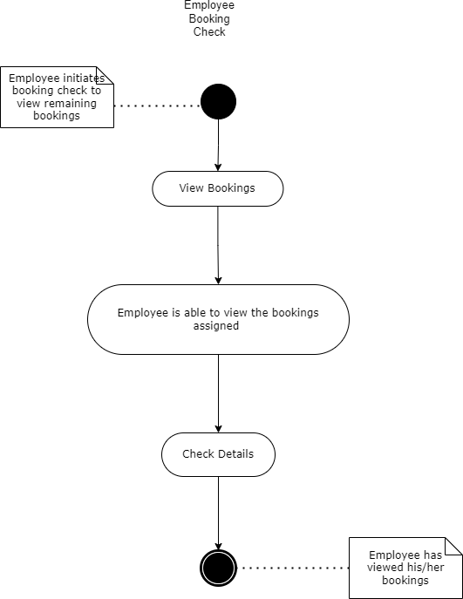

*Figure 41: Activity Diagram-BM (3)*

The above activity diagram reflects the action carried out employee view the booking details and status. At the end of this activity user will be able to view the booking details and status after fetching it from database.

## Sequence Diagram

* + User Booking

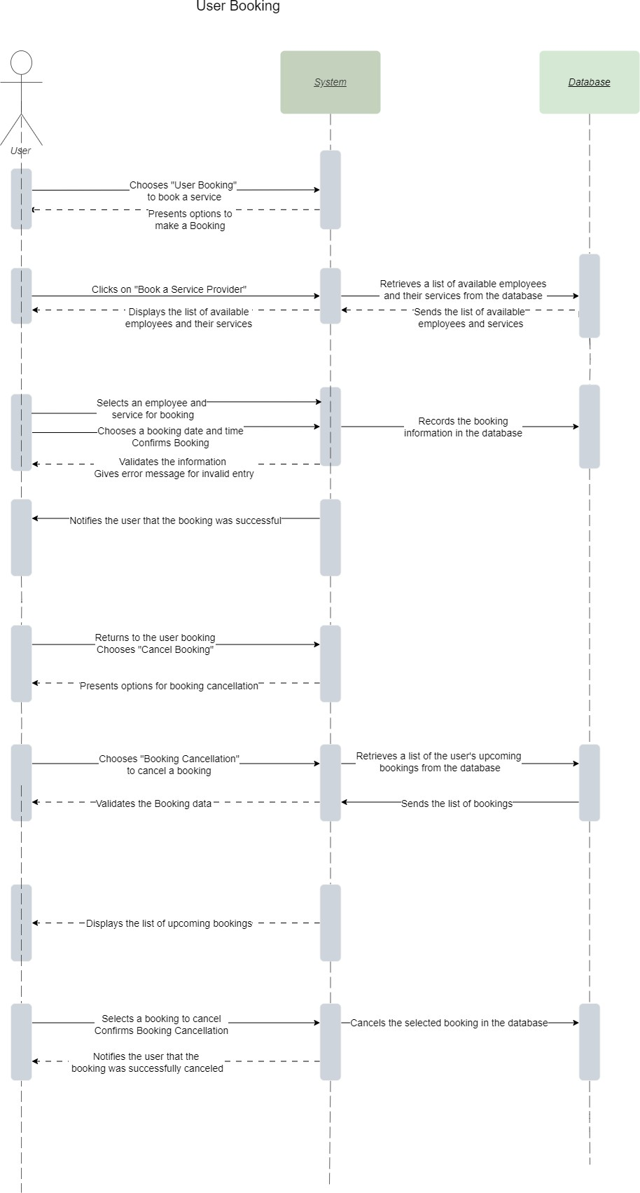

*Figure 42: Sequence Diagram-BM (1)*

The above sequence diagram shows the interaction between user (action) and other components of the system. It showcases the interaction occurring during user booking and user booking cancellation activity.

* + Employee Booking

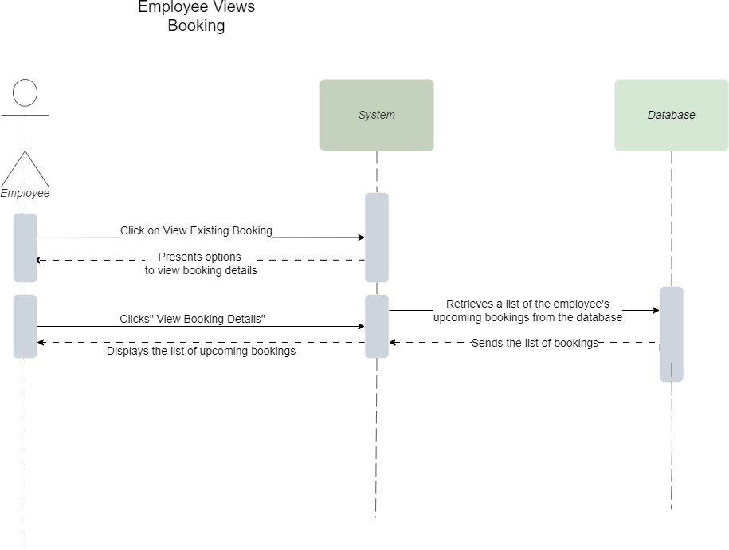

*Figure 43: Sequence Diagram-BM (2)*

The above sequence diagram shows the interaction between employee (action) and other components of the system. It shows the interaction occurring during employee booking activity. The sequence diagram shows all the interaction that employee faces while trying to view the booking details and status.

## Wireframe

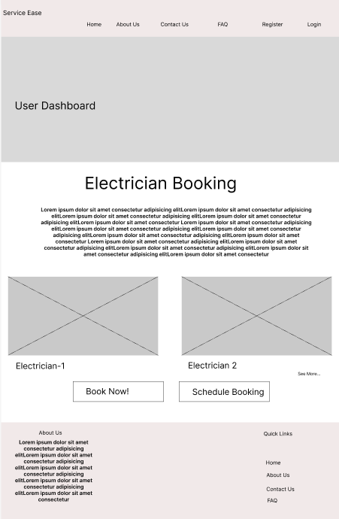

*Figure 44: Wireframe Design-BM (1)*

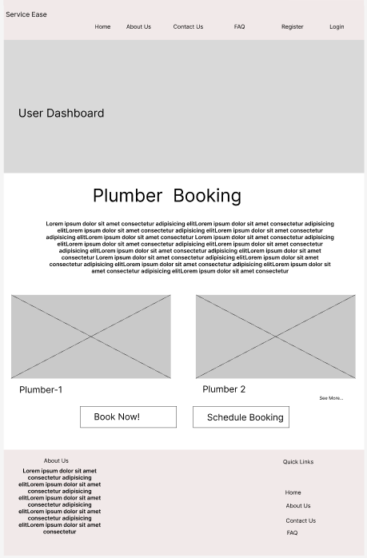

*Figure 45: Wireframe Design-BM (2)*

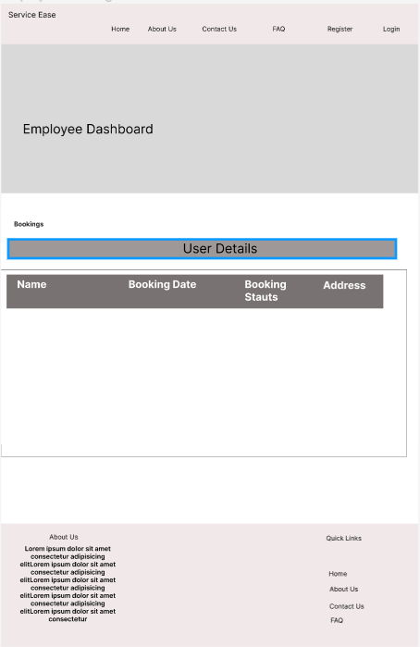

*Figure 46: Wireframe Design-BM (3)*

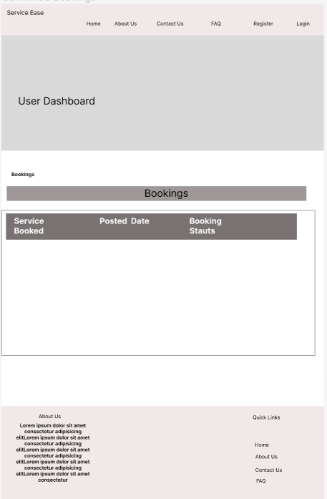

*Figure 47: Wireframe Design-BM (4)*

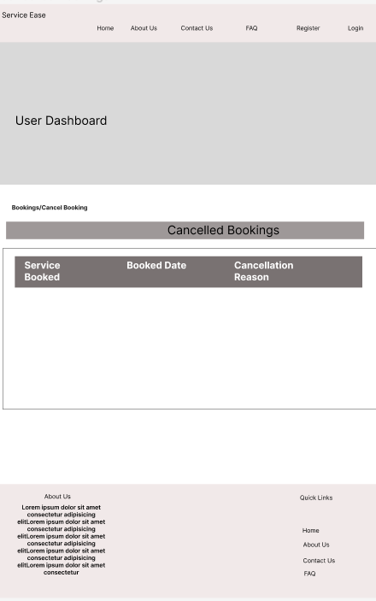

*Figure 48: Wireframe Design-BM (5)*

## Communication Diagram

* + User Booking

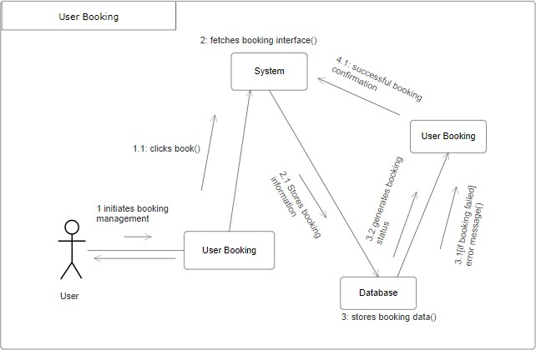

*Figure 49: Communication Diagram-BM (1)*

The above communication diagram shows the messages exchanged between the different system components while user is trying to book an employee. It shows the interaction to occur with the booking controller of the system.

* + Employee Booking

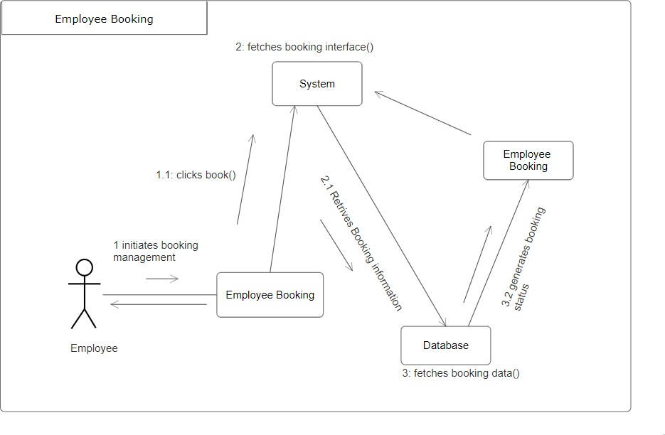

*Figure 50: Communication Diagram-BM (2)*

The above communication diagram shows the messages exchanged between the different system components while employee tries to view the user booking. It shows the interaction to occur with the booking controller of the system.

* + User Booking Cancellation

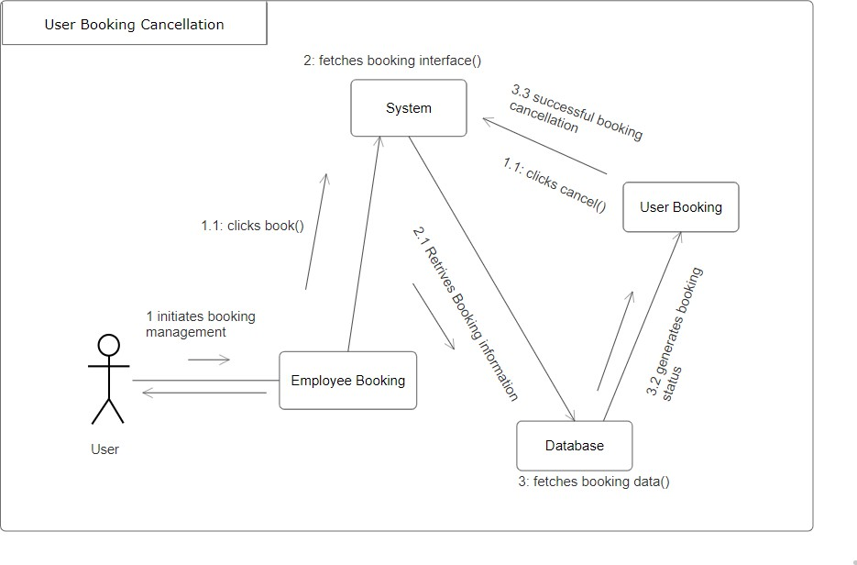

*Figure 51: Communication Diagram-BM (3)*

The above communication diagram shows the messages exchanged between the different system components while user tries to cancel a booking. It shows the interaction to occur with the booking controller of the system.

Feedback Management

## Use case

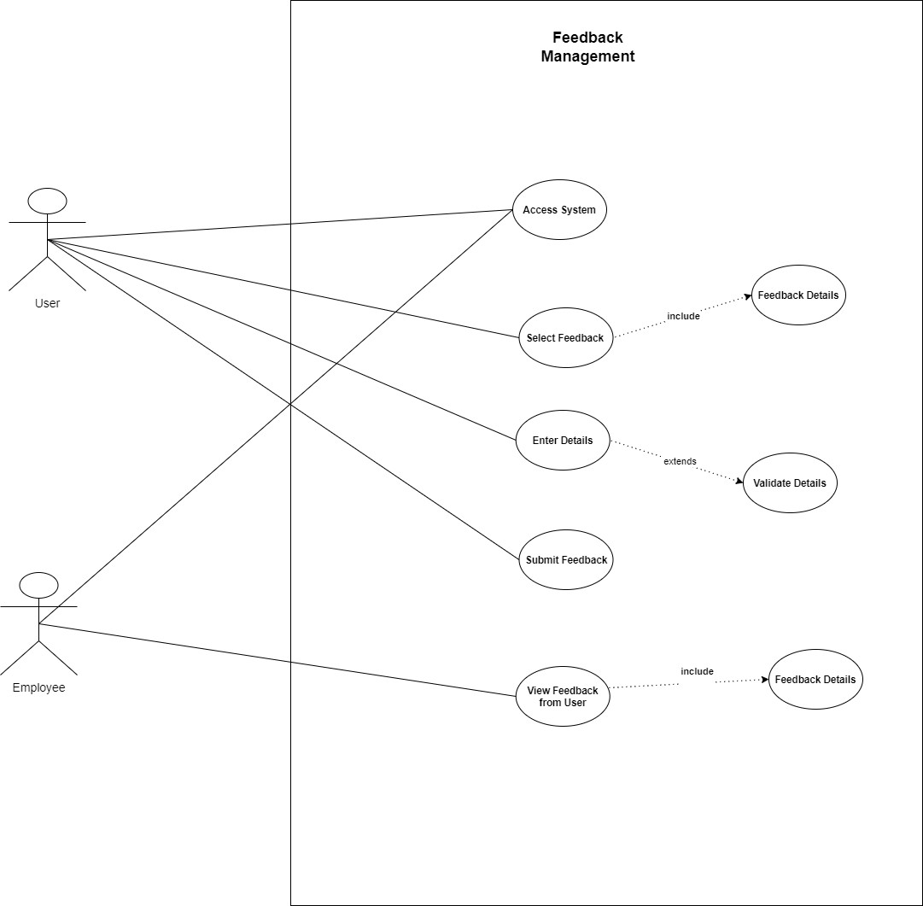

*Figure 52: Use Case-UEF*

The above use case shows the flow of feedback management artefact. User and employee are the two actors in the use case. The flow helps us to understand how feedback management works in this system.

## Activity Diagram

* + **User Feedback**

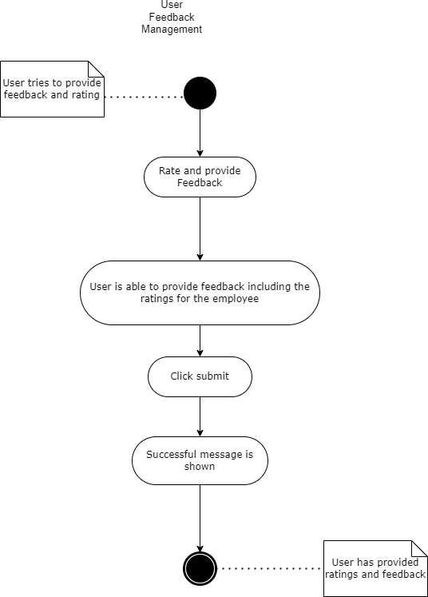

*Figure 53: Activity Diagram-UEF (1)*

The above activity shows how user is able to provide feedback to the employee. The user actions to perform this task is shown in the diagram above. At the completion of this activity user has successfully provided feedback to the employee.

* + Employee Views Feedback

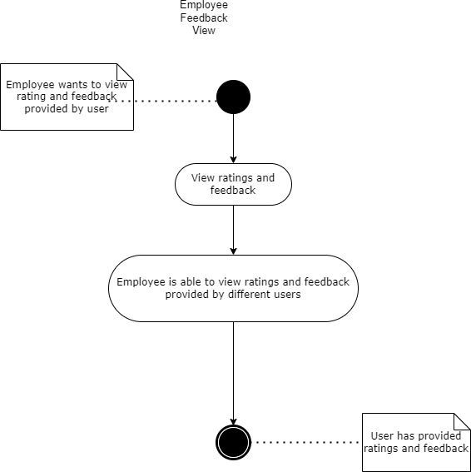

*Figure 54: Activity Diagram-UEF (2)*

The above activity shows how employee is able to view the received feedback. The employee actions to perform this task is shown in the diagram above. At the completion of this activity employee can view the feedbacks received.

## Sequence Diagram

* + User Feedback

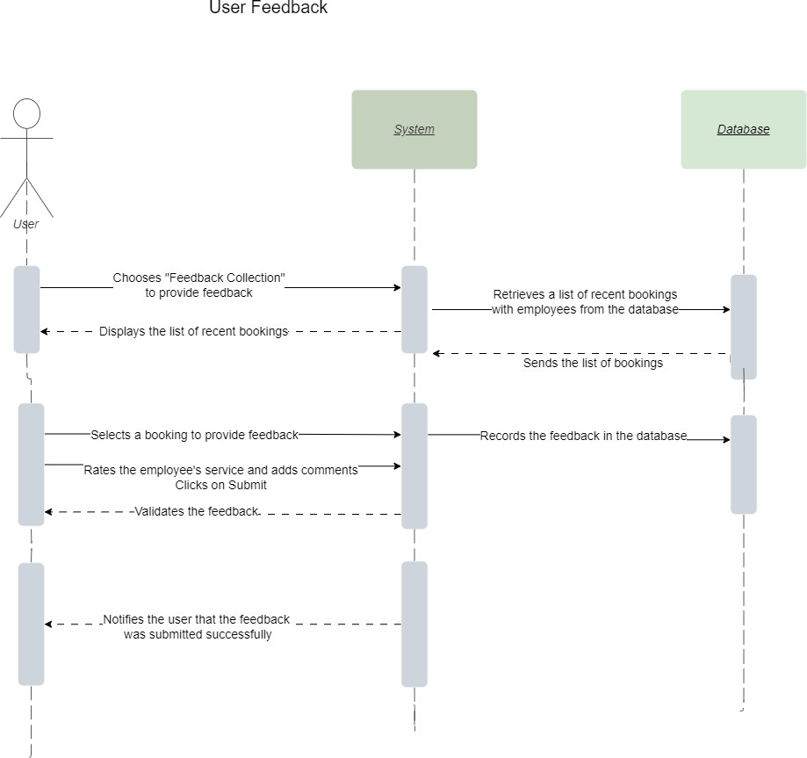

*Figure 55: Sequence Diagram-UEF (1)*

The sequence diagram above shows the interaction of the user while trying to provide feedback. It shows all the interaction between different components of the system while performing user feedback activity.

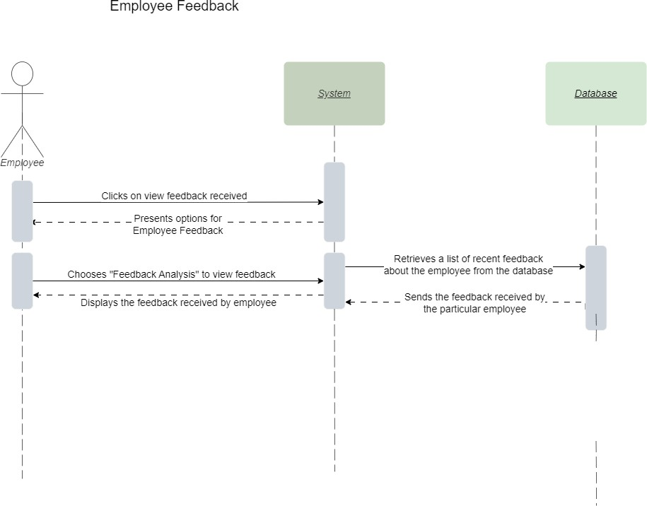

*Figure 56: Sequence Diagram-UEF (2)*

The sequence diagram above shows the interaction of the employee while viewing the user given feedback. It shows all the interaction between different components of the system while performing employee views feedback activity.

## Wireframe Design

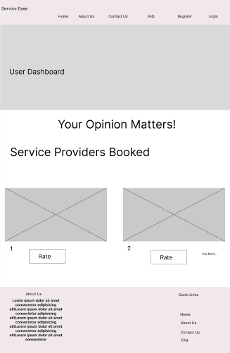

*Figure 57: Wireframe Design-UEF (1)*

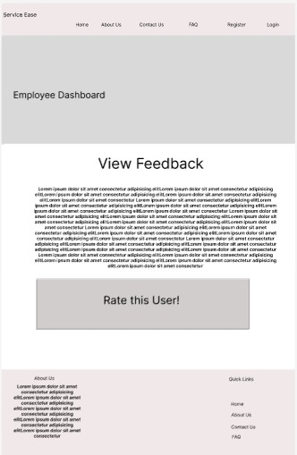

*Figure 58: Wireframe Design-UEF (2)*

## Communication Diagram

* + **User Feedback**

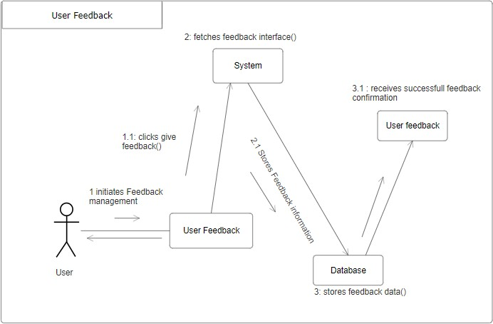

*Figure 59: Communication Diagram-UEF (1)*

The above communication diagram shows the messages exchanged between the different system components while user tries to rate the employee. It shows the interaction to occur with the feedback controller of the system.

* + Employee Feedback

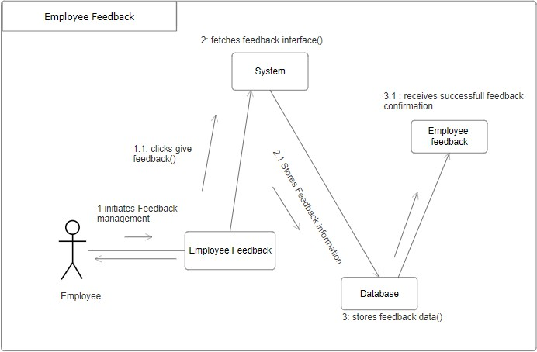

*Figure 60: Communication Diagram-UEF (2)*

The above communication diagram shows the messages exchanged between the different system components when employee views the feedback received. It shows the interaction to occur with the feedback controller of the system.

# Entity Relationship Diagram

Conceptual ERD

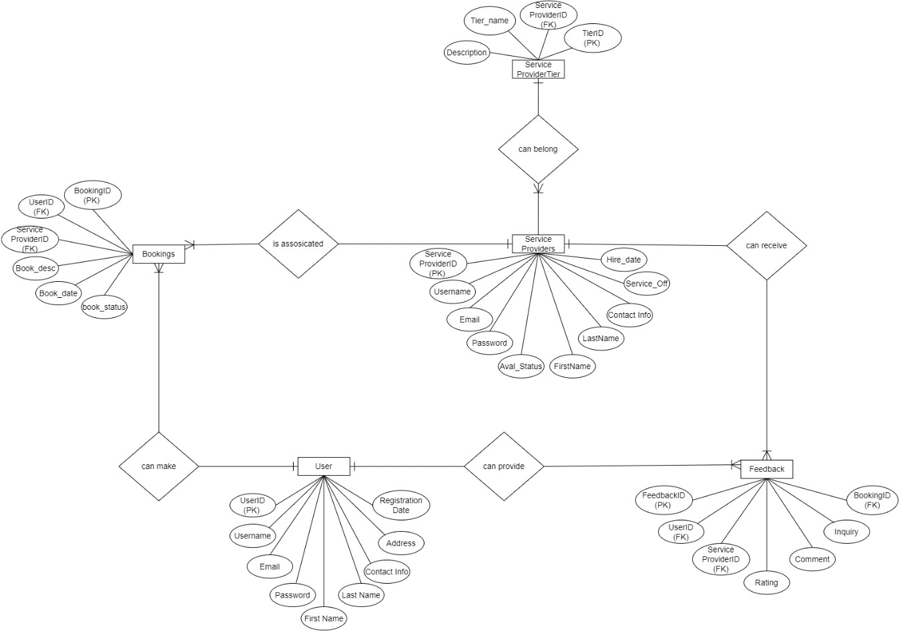

*Figure 61: Conceptual Erd*

Final ERD

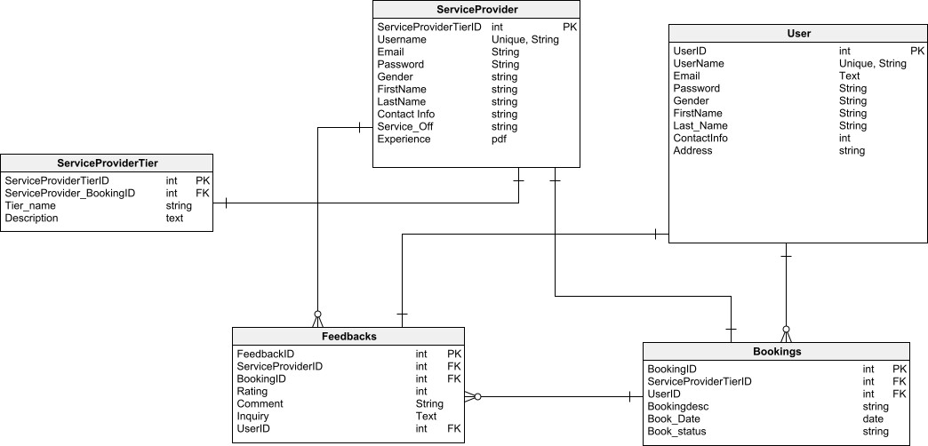

*Figure 62: Detailed ERD*

# Class Diagram

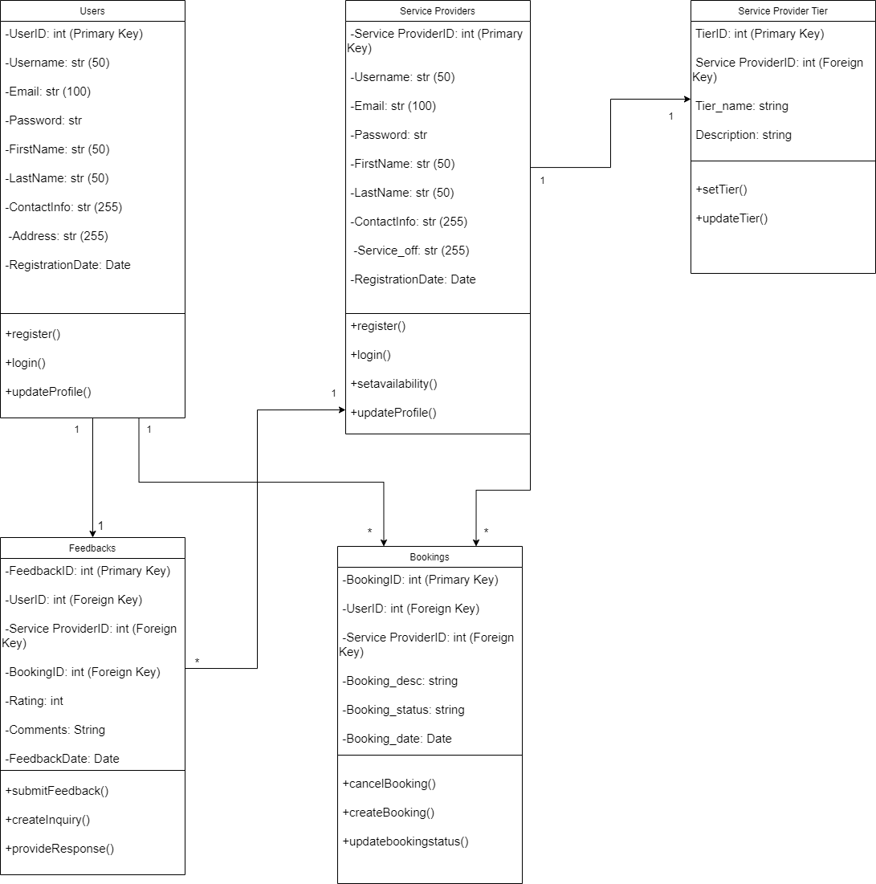

*Figure 63: Class Diagram*

# Data Dictionary

**User table**

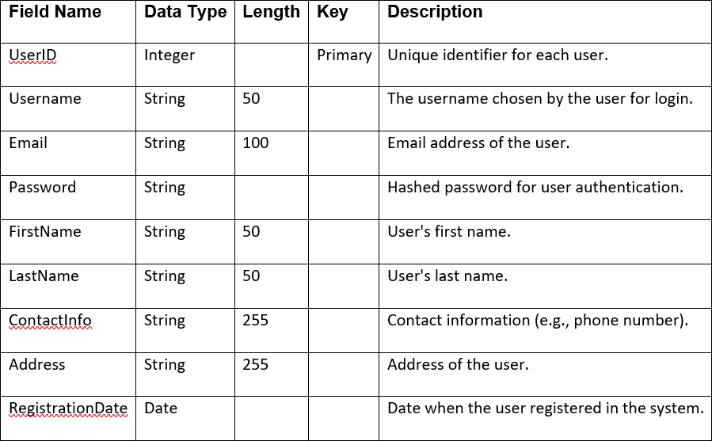

**Service Provider table**

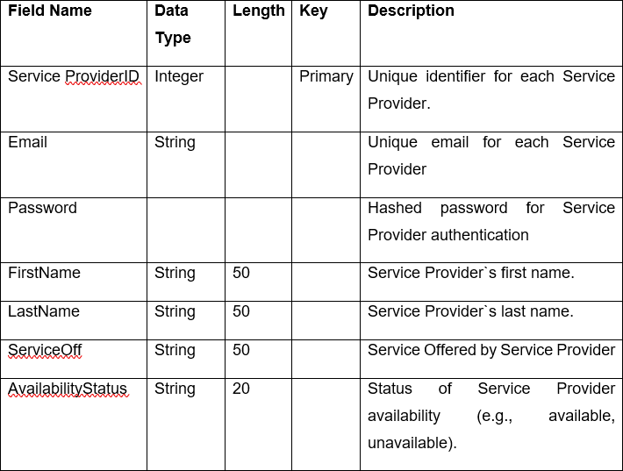

**Service Provider Tier table**

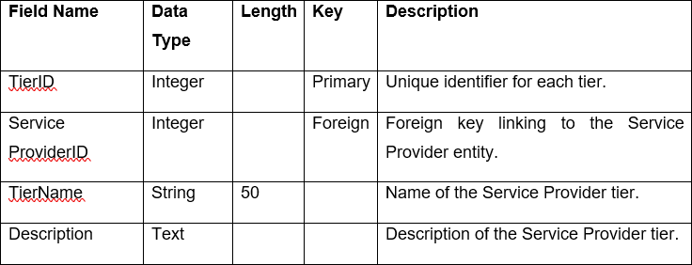

**Bookings Table**

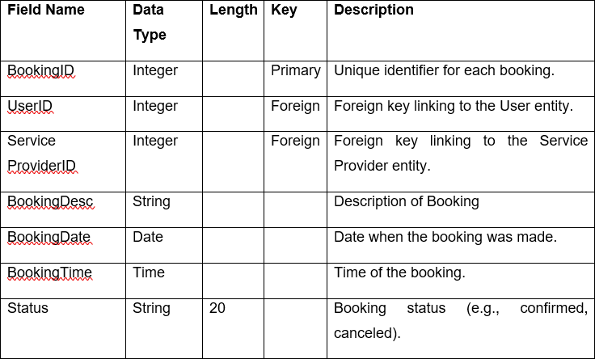

**Feedback table**

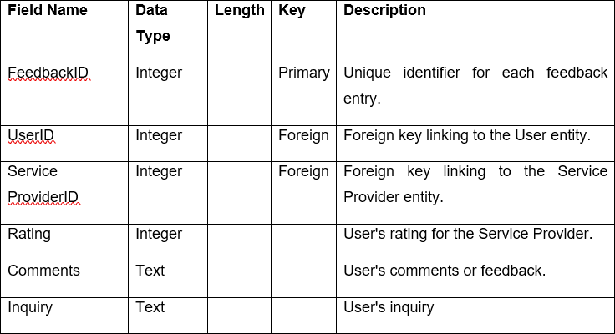

# Test plan

## Registration and login system

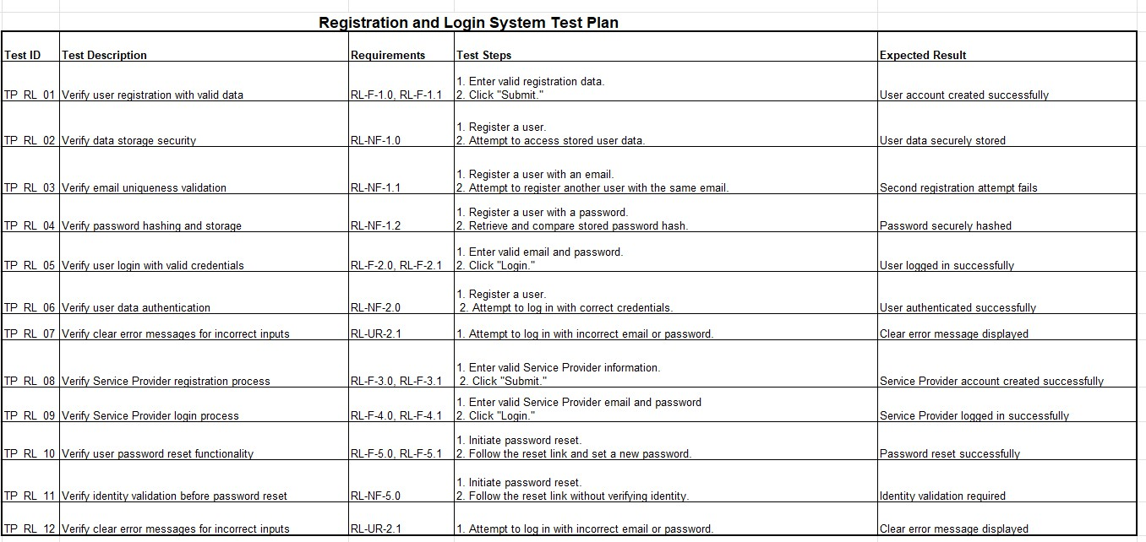

*Figure 64: Test Plan-RL*

## User Management

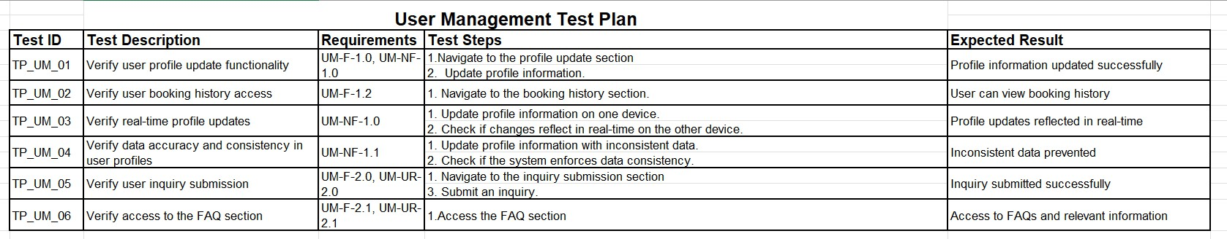

*Figure 65: Test Plan-UM*

## Employee Management

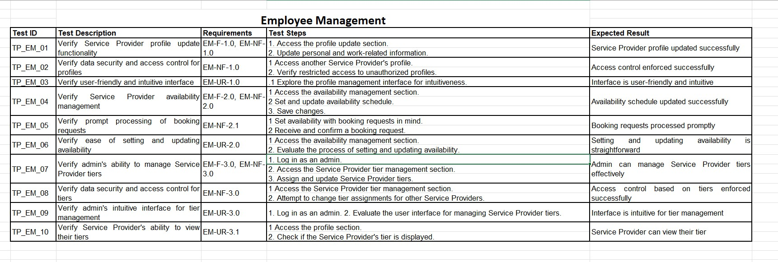

*Figure 66: Test Plan-EM*

## Booking Management

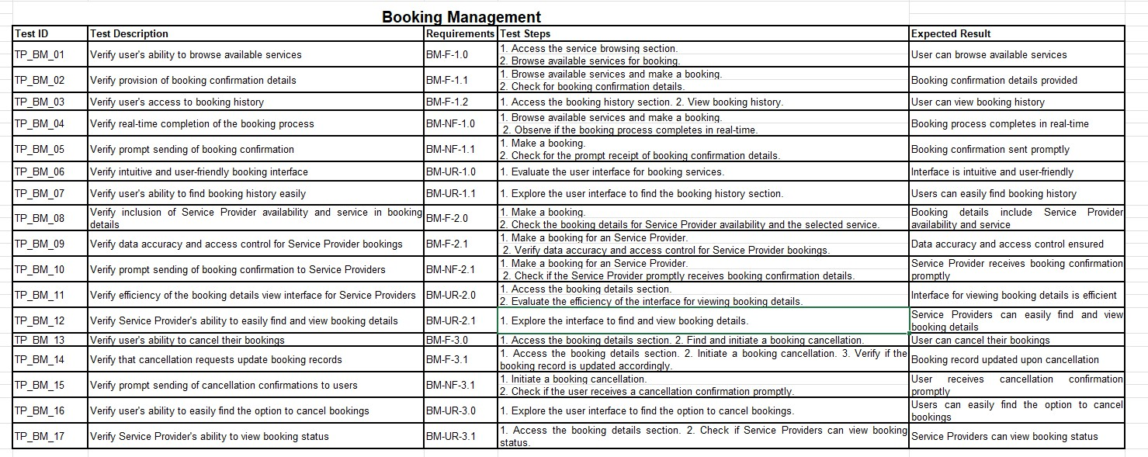

*Figure 67: Test Plan-BM*

## Feedback Management

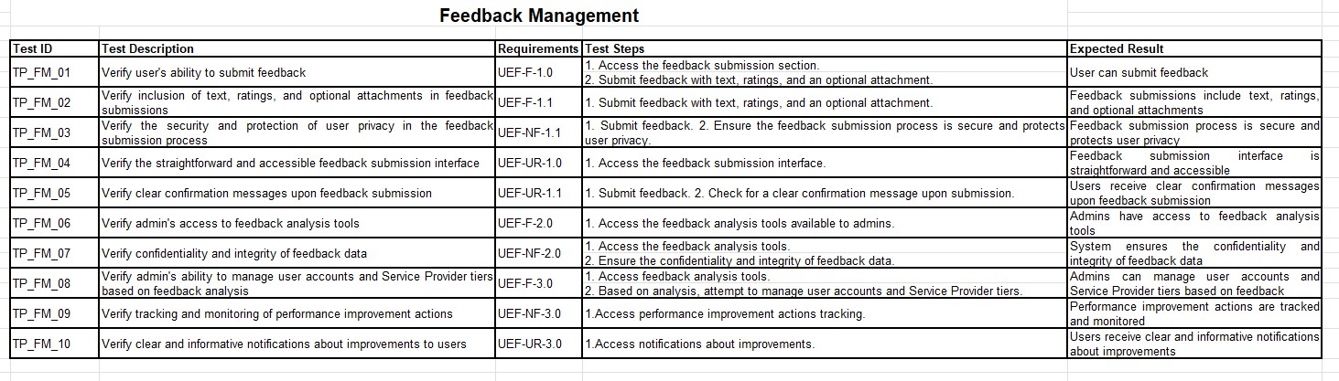

*Figure 68: Test Plan-UEF*

# SRS document

**Registration and login**

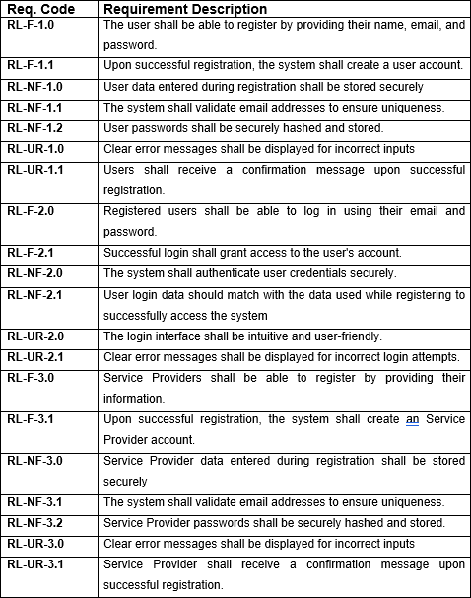

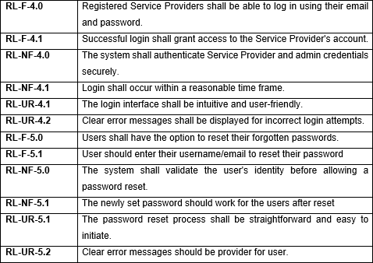

**User Management**

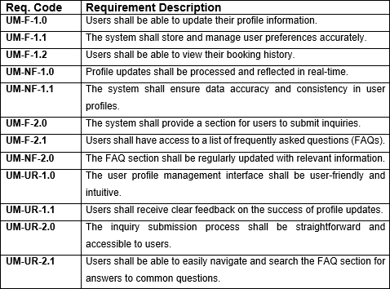

**Employee Management**

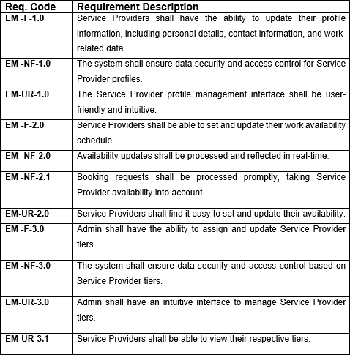

**Booking Management**

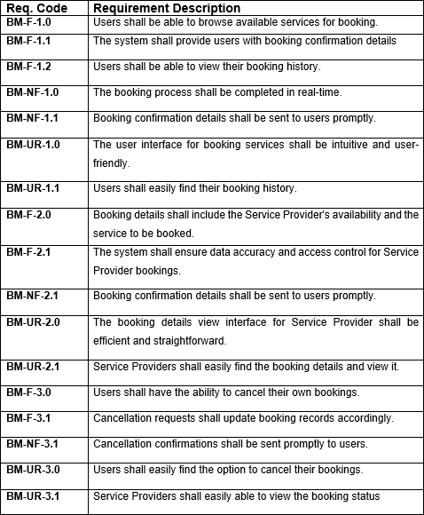

**User and Employee Feedback**

